St. Mary of the Seven Dolors
Catholic Church

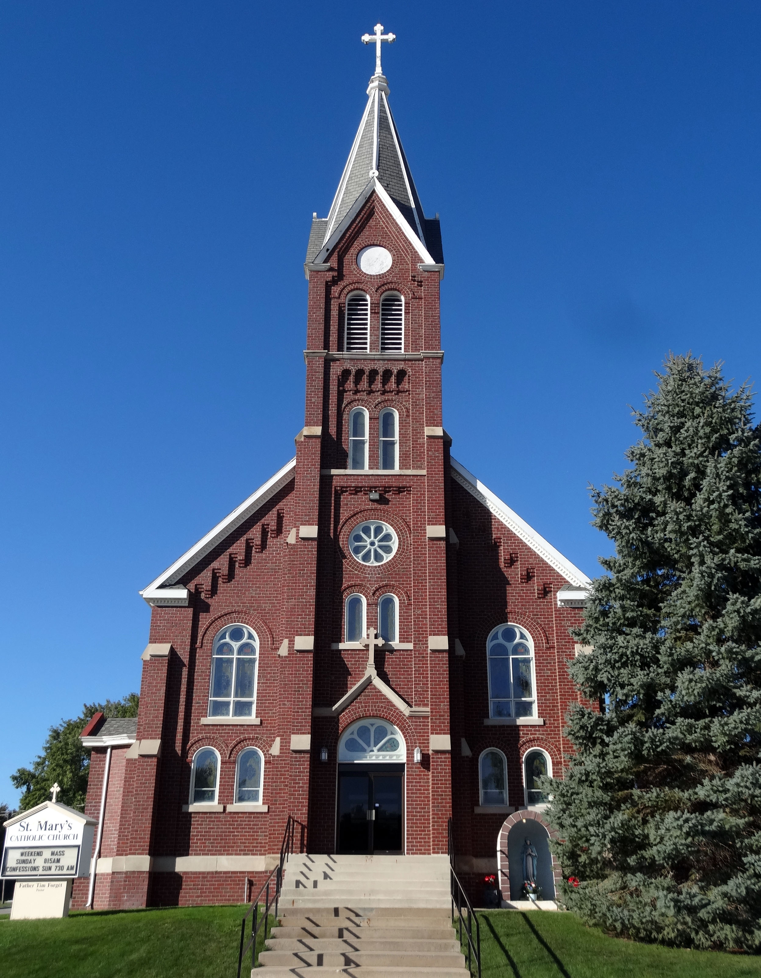

Book of Prayers

Table of Contents
St. Mary of the Seven Dolors 6
Seven Sorrows of Mary 6
Come Holy Spirit 7
Prayer of Jabez 7
Saint Theresa’s Prayer 7
St. Jane Frances de Chantal 8
St. Jane Frances de Chantal 8
The Difference 8
Prayer for Blessing on the Land 9
Prayer to St. Isidore(Patron Saint of the Internet) 9
The Angelus 10
Regina Caeli 10
To Saint Joseph 11
To the Sacred Heart 11
To the Blessed Sacrament 11
Daily Prayer 12
The Holy Rosary 13
How to Pray the Rosary 13
Prayer Before the Rosary 14
Joyful Mysteries 14
Sorrowful Mysteries 16
Glorious Mysteries 18
Luminous Mysteries 20
Rosary of the Seven Sorrows 22
Chaplet of Divine Mercy 24
Teenage Prayer 26
Prayer for Priests and Seminarians 27
Emmaus Prayer for Priests 27
Prayer for Vocations 28
Parents Prayer for Vocations 28
For Youth and for Vocations 29
Prayer to St. Jude 29
Prayer for a Happy Death 30
Litany of the Sacred Heart of Jesus 30
Litany of the Blessed Virgin 32
Litany of St. Joseph 34
Prayer to Prepare for Mass 35
Short Preparation for Mass 35
Act of Faith 35
Act of Humility 36
Act of Sorrow 36
Table of Contents continued
Act of Adoration 36
Act of Love and Desire 36
Short Thanksgiving After Holy Communion 36
Act of Faith 36
Act of Adoration 36
Act of Humility 36
Act of Love 36
Act of Thanksgiving 36
Act of Offering 37
Prayer for Others 37
Prayer for Yourself 37
Long Preparation for Mass 38
Prayer of St. Ambrose 38
Thanksgiving After Mass and Communion 39
Psalm 150 40
Prayer of St. Thomas Aquinas 41
Prayer Before the Crucifix 41
The Memorare 42
Prayer for Peace 42
Campaign Prayer 43
The Way of the Cross 43
Station 1 43
Station 2 44
Station 3 44
Station 4 44
Station 5 45
Station 6 45
Station 7 45
Station 8 45
Station 9 46
Station 10 46
Station 11 46
Station 12 46
Station 13 47
Station 14 47
A Quarter of an Hour Before the Blessed Sacrament 47
Seven Penitential Psalms 50
Psalm 6: Prayer in Ordeal 50
Psalm 32: Candid Admission of Sin 50
Psalm 38: Prayer in Distress 51
Psalm 51: Miserere 52
Table of Contents continued
Psalm 102: Prayer in Misfortune 53
Psalm 130: From the Depths 55
Psalm 143: A Humble Entreaty 55
Anima Christi 56
Christ be with Me 57
Jesus King 57
Oh Joy 57
Ten Commandments 58
The Sacrament of Reconciliation 58
How to Go to Confession 58
Act of Contrition 59
Preparation for Confession 59
Reading: Luke 15:1-7 59
Examination of Conscience 60
I. The Lord says: “You shall love the Lord Your
God with Your whole heart 60
II. The Lord says: “Love one another as I have
loved You.” 61
III. Christ our Lord says: “Be perfect as Your
Father is perfect 63
Jesus Prayer 64
Thanksgiving After Confession 64
The Magnificat 64
Prayer of Thanksgiving 64
Novena to St. Joseph 65
Healing Prayers 66
Additional Daily Prayers 66
Morning Prayer 66
A Morning Prayer 67
Prayer in Time of Need 67
Evening Prayer 67
Evening Prayer 67
Psalm 23 – The Good Shepherd 67
Psalm 27 – In God’s Company There is no Fear 68
Psalm 130 69
Serenity Prayer 69
Prayer of Thanksgiving 69
Prayers for the Sick 70
Prayer for the Addicted 70
Prayer to St. Alphonsus (Patron of
Arthritis Sufferers) 71
Table of Contents continued
In Thanksgiving for a Favor Received 71
Prayer of Spouses for Each Other 72
Prayer to End Abortion 72
Prayer for Our Nation 73
O Salutaris Hostia 73
Our Father - Pater Noster 74
Hail Mary – Ave Maria 74
Tantum Ergo 74
Seven Sorrows Picture 75

St. Mary of the Seven Dolors
St. Mary’s patron saint, Our Lady of Sorrows, is honored with a feast day on September 15th.
This is the patron saint of all St. Mary’s parishioners and all
Christian Mothers.

Below are the seven sorrows of Mary:
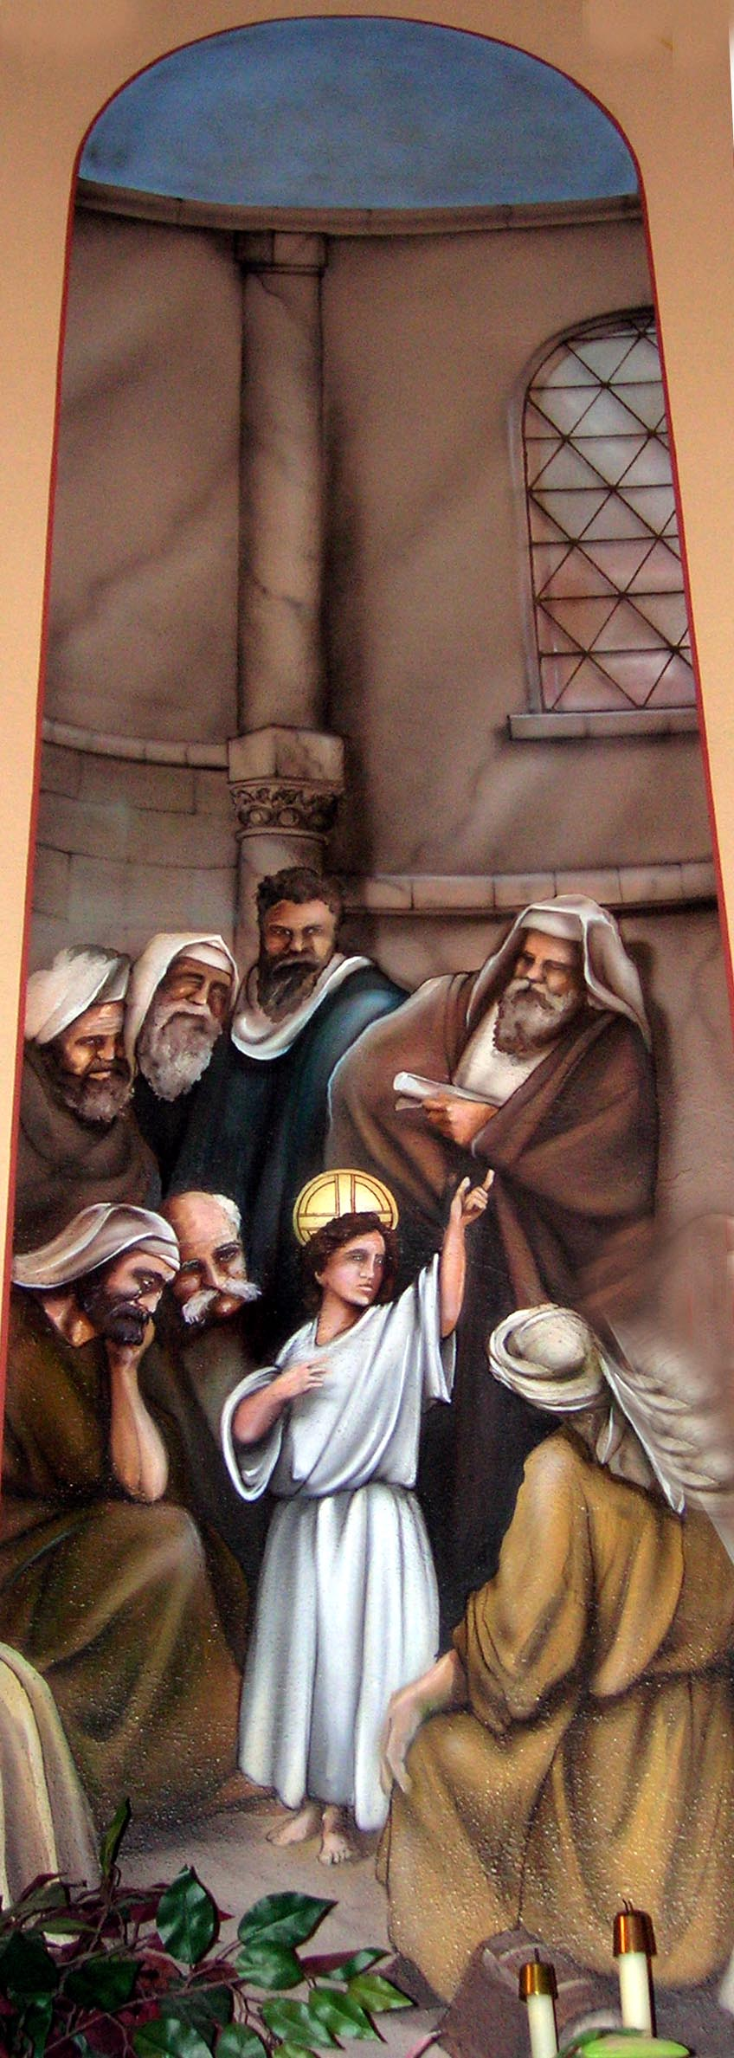
Sorrow 1 Sorrow 2 Sorrow 3 Sorrow 4
Prophecy Flight into Loss of Jesus Way to
Of Simeon Egypt for three days Calvary

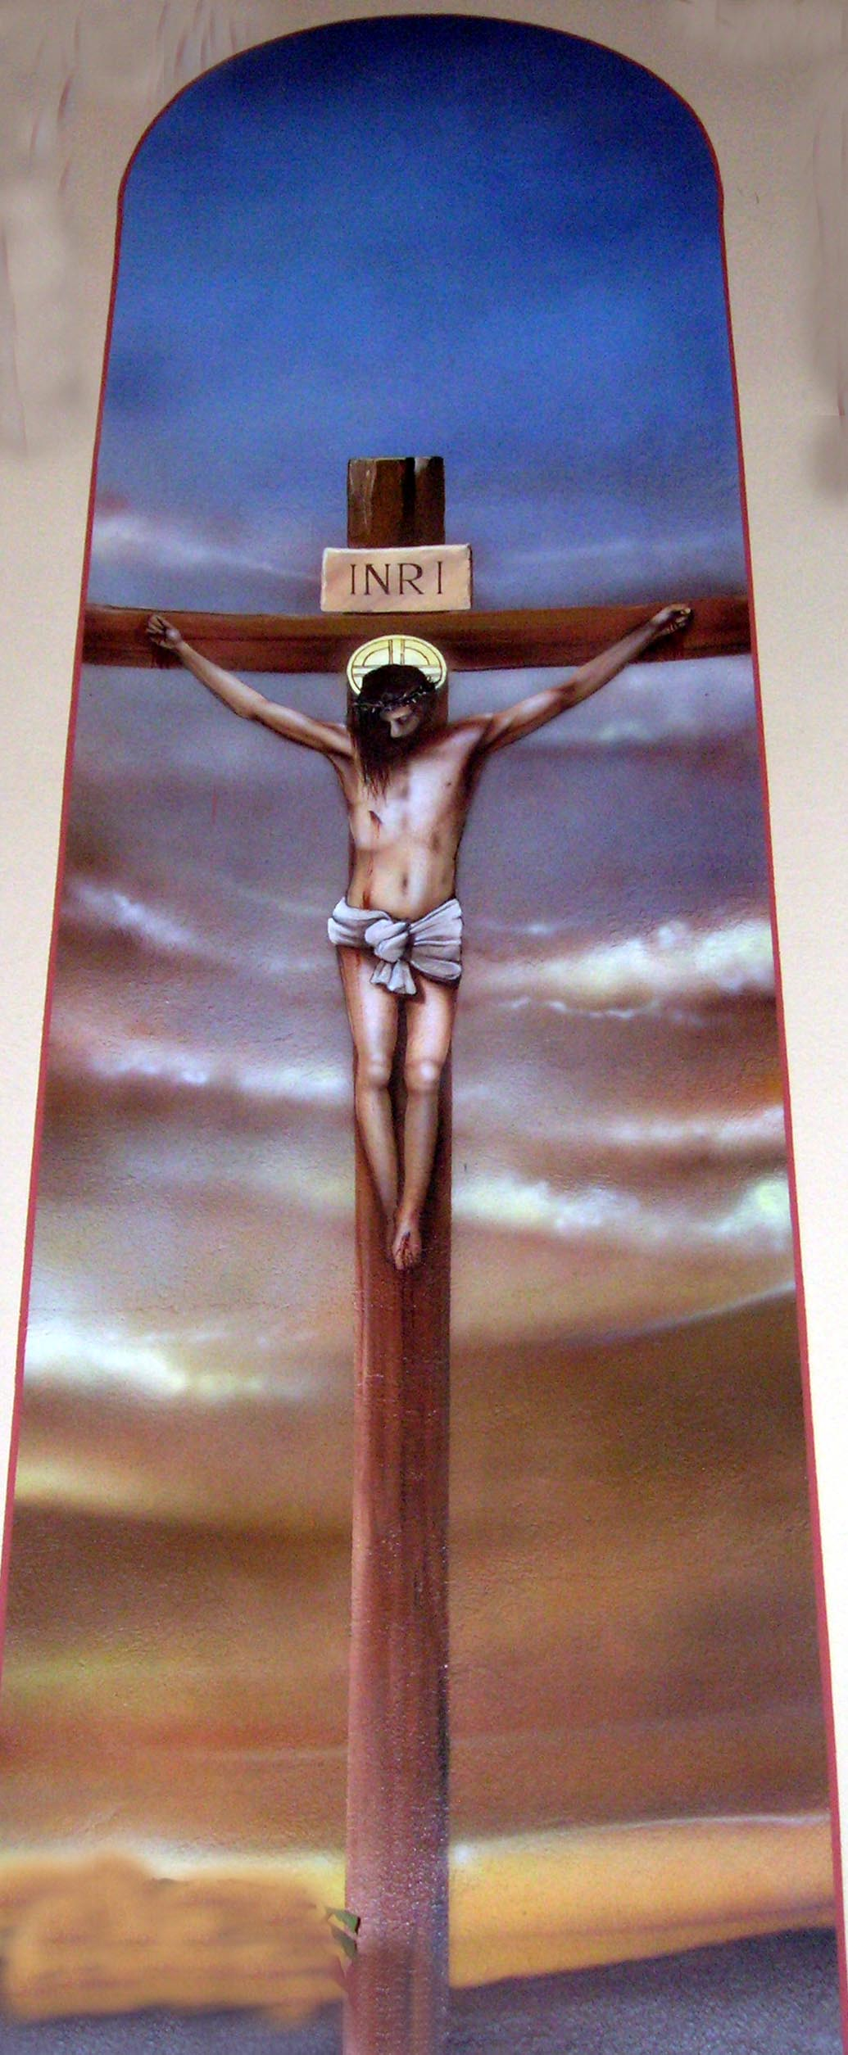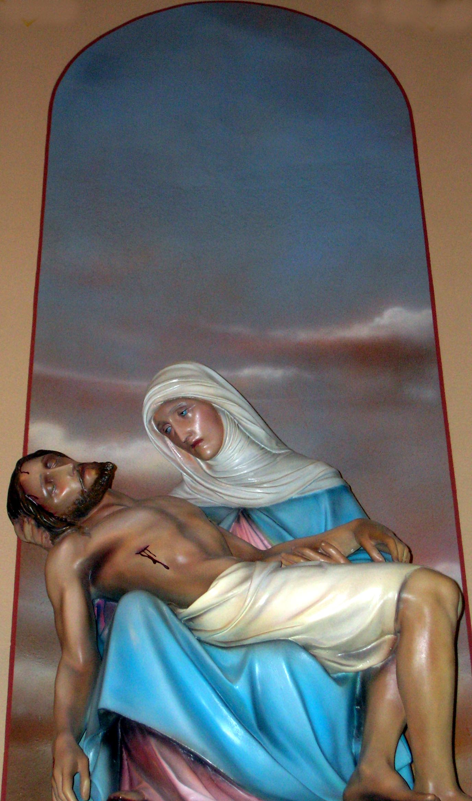
Sorrow 5 Sorrow 6 Sorrow 7
Crucifixion Descent from Cross Burial of Jesus

Come Holy Spirit
Come Holy Spirit, fill the hearts of your faithful and kindle in them the fire of your love. Send forth your Spirit and they shall be created. And You shall renew the face of the earth.
O, God, who by the light of the Holy Spirit, did instruct the hearts of the faithful, grant that by the same Holy Spirit we may be truly wise and ever enjoy His consolations, Through Christ Our Lord, Amen.

Prayer Of Jabez
"And Jabez called on the God of Israel, saying, Oh that Thou wouldest bless me indeed, and enlarge my coast, and that Thine hand might be with me, and that Thou wouldest keep me from evil, that it may not grieve me! And God granted him that which he requested."

Saint Theresa’s Prayer
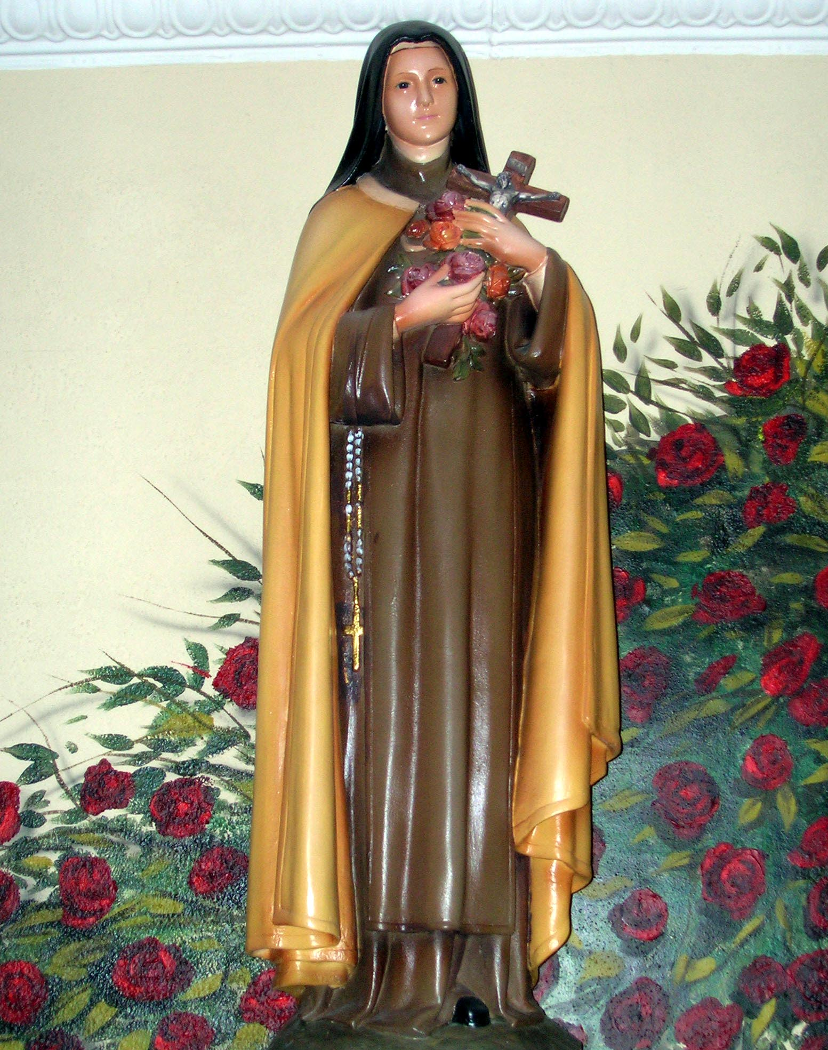
May today there be peace within.
May you trust God that you are exactly where you
are meant to be.
May you not forget the infinite
possibilities that are born of faith.
May you use those gifts that you have received,
and pass on the love that has been given to you.
May you be content knowing you are a child of God.
Let this presence settle into your bones,
and allow your soul the freedom to sing,
dance, praise and love.
It is there for each and every one of us.

St. Jane Frances de Chantal

Lord, you chose Saint Jane Frances to serve you both in marriage and in religious life. By her prayers help us to be faithful in our vocation and always to be the light of the world. We ask this through our Lord Jesus Christ, your Son, who lives and reigns with you and the Holy Spirit, one God, for ever and ever. Amen.

St. Jane Frances de Chantal
Saint Jane, you forgave the man who killed your husband. Help me learn to forgive a particular person in my life who has caused me harm. You know how difficult it is to forgive. Help me to take the steps you took to welcome this person back into my life. Amen.

The Difference
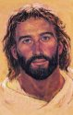
I got up early one morning
And rushed right into the day;
I had so much to accomplish
That I didn’t have time to pray.

Problems just tumbled about me,
And heavier came each task.
“Why doesn’t God help me?” I wondered.
He answered, “You didn’t ask.”
I wanted to see joy and beauty,
But the day toiled on, gray and bleak;
I wondered why God didn’t show me
He said, “But you didn’t seek.”

I tried to come into God’s presence;
I used all my keys at the lock.
God gently and lovingly chided,
“My child, you didn’t knock.”

I woke up early this morning,
And paused before entering the day;
I had so much to accomplish
That I had to take time to pray.

Prayer For Blessing On The Land

Almighty God, merciful Father, kind preserver of our life from whom we daily receive our bread and all that is needed for our sustenance, we beseech thee to bless our fields. Give growth and increase to the fruits of the earth; send refreshing rain and mild sunshine at seasonable times. Preserve our crops and give us a rich harvest so that we might share with others the blessings you have offered to us, your grateful children. Amen.

Prayer To St. Isidore
Patron Saint of the Internet
Almighty and eternal God who has created us in thine image and bade us to seek after all that is good, true and beautiful, especially in the divine person of Thy only-begotten Son, Our Lord Jesus Christ, grant we beseech Thee that through the intercession of Saint Isidore, bishop and doctor, during our journeys through the internet we will direct our hands and eyes only to that which is pleasing to Thee and treat with charity and patience all those souls whom we encounter. Father we ask you this, through Christ our Lord. Amen

The Angelus
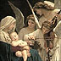
The Angel of the Lord declared unto Mary,
And she conceived of the Holy Spirit,
Hail Mary…

Behold the handmaid of the Lord;
Be it done unto me according to Your word.
Hail Mary…

The Word was made flesh
And dwelt among us
Hail Mary…

Pray for us, O holy Mother of God,
That we may be made worthy of the promises of Christ.

Let us pray,
Pour forth, we beseech You, O Lord, Your grace into our hearts, that we, to whom the incarnation of Christ, Your Son, was made known by the message of an angel, may, by His passion and cross, be brought to the glory of His resurrection, through Christ our Lord. Amen.

Regina Caeli (Replaces the Angelus at Eastertime)
Queen of heaven, rejoice. Alleluia.
For He whom you deserved to bear. Alleluia.
Has risen as He said. Alleluia.
Pray for us to God. Alleluia.
Rejoice and be glad, O Virgin Mary. Alleluia.
For the Lord is truly risen. Alleluia.
Let us pray, O God, who by the resurrection of Your Son, our Lord Jesus Christ, vouchsafed to give joy to the whole world; grant, we beseech You, that through the intercession of the Virgin Mary, His Mother, we may attain to joys of eternal life. Through Christ our Lord. Amen.

To Saint Joseph
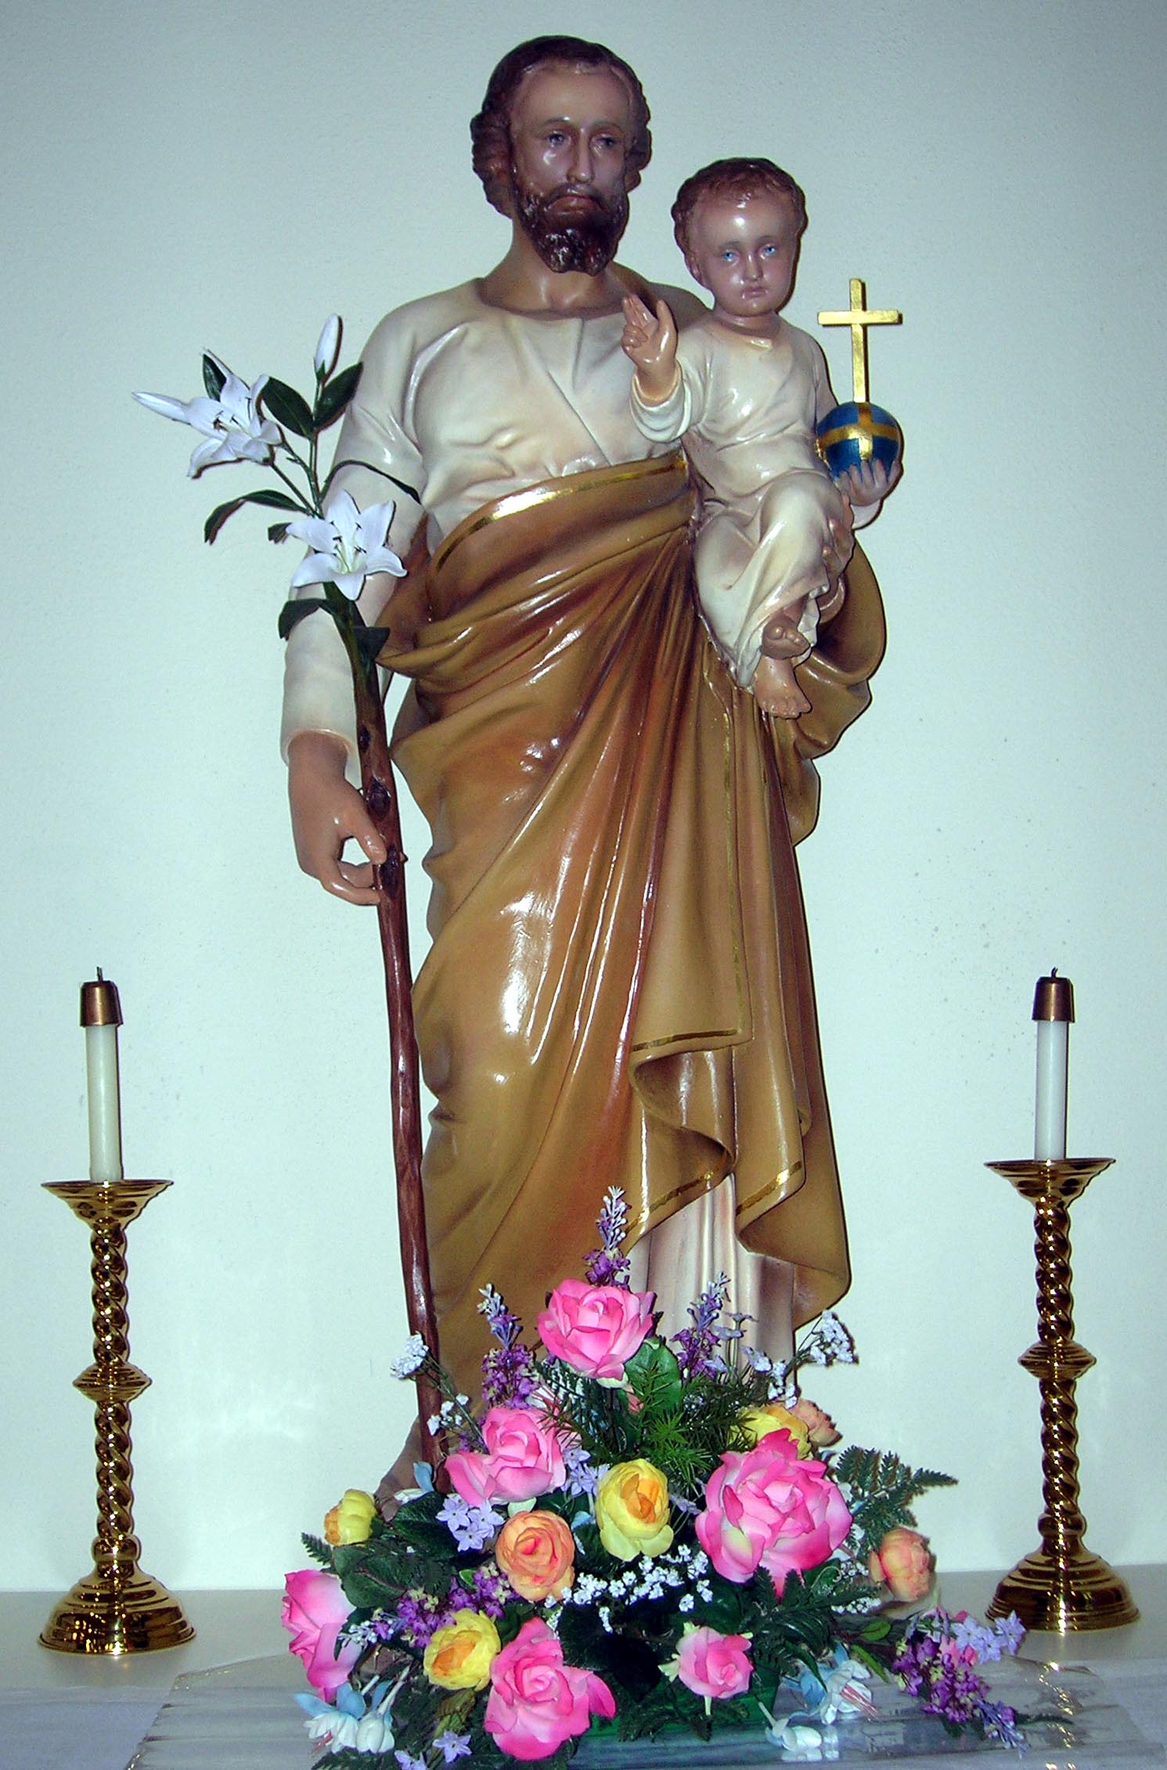
Saint Joseph, I choose You today as my model, my protector and my father. Receive me as one of Your privileged children. I will do my best to show myself worthy of You till death. Amen
-Josephite Devotions

To The Sacred Heart
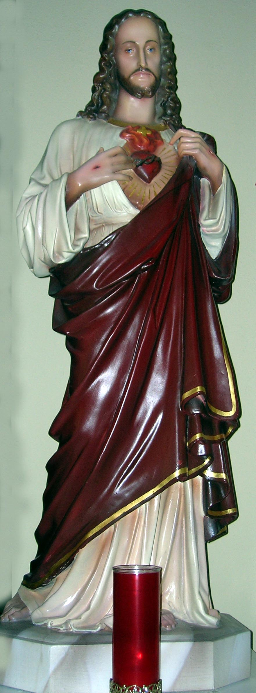
Most Sacred Heart of Jesus, we consecrate ourselves to You. Bless our family, our home and our undertakings. Grant us the grace to fulfill all our duties as well as we can. Give us peace and confidence, console us in our sufferings, and make us always love You more and more. Most Sacred Heart of Jesus.
May Your kingdom come.
-Josephite Devotions

To The Blessed Sacrament
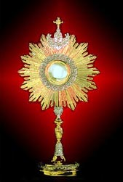
O holy banquet, in which Christ is received, in which the memory of His passion is renewed, in which the soul is filled with grace and a pledge of future glory is given to us. (T.P. Alleluia)

You furnished them bread from heaven (Alleluia). Endowed with all delight. (Alleluia).
Let us pray.
Lord Jesus, in a wonderful sacrament You have left us a memorial of Your passion. Grant us the grace to adore the hidden presence of Your body and blood with such faith that we may always feel within us the effects of Your redemption. This we ask of You, Lord Jesus, living and reigning with the Father and the Holy Spirit, one God, forever and ever. Amen
-St. Thomas Aquinas

Daily Prayer

Dear Lord, I thank You for this day. I thank You for my health and for being able to see and to hear this morning. I’m blessed because You are a forgiving God and an understanding God. You have done so much for me and You keep on blessing me. Forgive me this day for everything I have done, said or thought, that was not pleasing to You. I ask now for Your forgiveness.
Please keep me safe from all danger and harm. Help me to start this day with a new attitude and plenty of gratitude. Let me make the best of each and every day and help me to clear my mind so that I can hear from You.

Let me not whine and whimper over things I have no control over. Let me continue to see sin through God’s eyes and acknowledge it as evil. When I sin let me repent, and confess with my mouth my wrongdoing, and receive the forgiveness of God.

When this world closes in on me, let me remember Jesus’ example to slip away and find a quiet place to pray. It’s the best response when I’m pushed beyond my limits. I know that when I can’t pray, You listen to my heart. Continue to use me to do Your will.

Continue to bless me that I may be a blessing to others. Keep me strong that I may help the weak. Keep me uplifted that I may have words of encouragement for others. I pray for those that are lost and can’t find their way. I pray for those that are confused, misjudged and misunderstood. I pray for those who don’t know You intimately. I pray for those that don’t believe in You. I thank You that I do believe in You and Your power.

I believe that God changes people and God changes things! I pray for my children, my mother and father, and all of my brothers and sisters. I pray for each and every family member and their households. I pray for peace, love, and joy in their homes; and that they are able to get free from debt, and that all of their needs are met.

I pray that every eye that reads this will know that there is no problem, circumstance or situation greater than You, God. Every battle is in Your hands, for You to fight. I pray that these words be received into the hearts of every eye that sees them and every mouth that confesses them willingly.

This is my prayer.
In Jesus Name, Amen.

The Holy Rosary
This is composed of twenty decades, each decade consisting of the Our Father, ten Hail Mary’s and the Glory Be, and each being recited in honor of some mystery (happening) in the life of our Lord and His Blessed Mother. During each decade we should call to mind the mystery which it is intended to honor, and pray that we may learn to practice the virtue specially taught us by that mystery.

How to Pray the Rosary
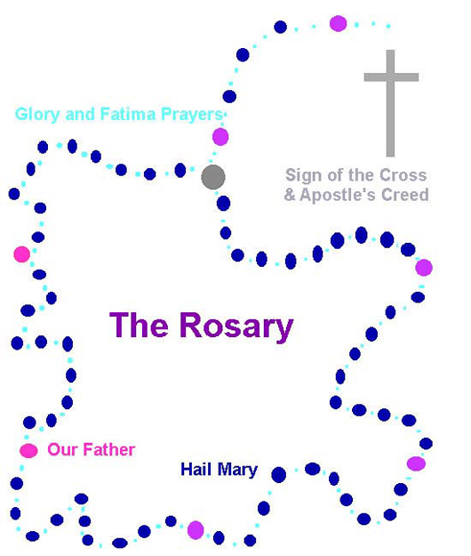
- Make the Sign of the Cross and say the “Apostles Creed.”
- Say the “Our Father.”
- Say three “Hail Mary’s.”
- Say the “Glory be to the Father.”
- Announce the First Mystery; then say the “Our Father.”
- Say ten “Hail Mary’s while meditating on the Mystery.
- Say the “Glory be to the Father..,” and “Oh, my Jesus forgive us…”
- Announce the Second Mystery; then say the “Our Father.”
Repeat 6 and 7 and continue with Third, Fourth and Fifth Mysteries in the same manner. Conclude with Glory Be…Oh, my Jesus forgive us, and the Hail Holy Queen.

Prayer before the Rosary: I believe in God, the Father Almighty, Creator of heaven and earth; and in Jesus Christ, His only Son, our Lord; Who was conceived by the Holy Spirit, born of the Virgin Mary, suffered under Pontius Pilate, was crucified, died and was buried. He descended into hell; the third day He rose again from the dead. He ascended into heaven, and is seated at the right hand of God, the Father Almighty; from thence He shall come to judge the living and the dead. I believe in the Holy Spirit, the holy Catholic Church, the communion of saints, the forgiveness of sins, the resurrection of the body, and life everlasting. Amen.

The Joyful Mysteries are said on
Monday and Saturday
The Joyful Mysteries are marked by the joy radiating from the event of the incarnation. This is clear from the very first mystery, the Annunciation, where Gabriel’s greeting to the Virgin of Nazareth is linked to an invitation to messianic joy: “Rejoice, Mary.” The whole of salvation…had led up to this greeting.

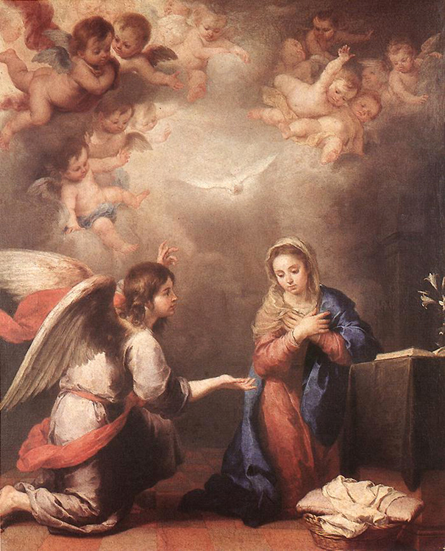First Joyful Mystery – The Annunciation – The angel Gabriel tells Mary she will have a son. The Angel Gabriel said to Mary: “Hail full of grace, the Lord is with You. Blessed are You among women…You shall conceive and bear a son, and You shall call His name Jesus”…Mary answered, “Behold the handmaid of the Lord: be it done to me according to Your word.” (Luke 1:28, 31, 38)
Second Joyful Mystery – The Visitation: Mary Visits Elizabeth – Elizabeth was filled with the Holy Spirit and cried out in a loud voice: “Blessed are You among women, and blessed is the fruit of Your womb…The moment Your greeting sounded in my ears, the babe in my womb leapt for joy.” (Luke 1:42-44)

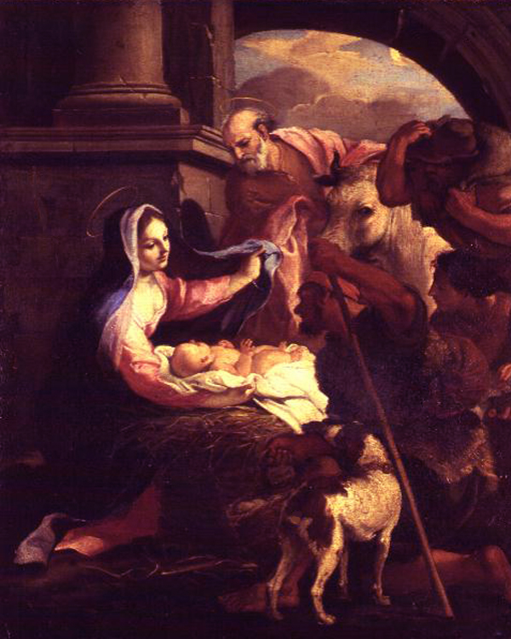Third Joyful Mystery – The Nativity – And it came to pass while they were there, that the days for Mary to be delivered were fulfilled. And she brought forth her firstborn son, and wrapped him in swaddling clothes and laid him in a manger, because there was no room for them in the inn. (Luke 2:6-7)

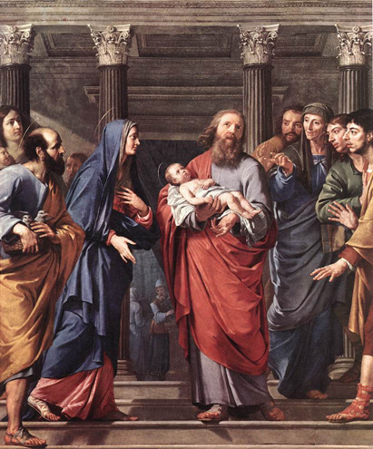Fourth Joyful Mystery – The Presentation – When the days of her purification were fulfilled they took him up to Jerusalem to present Him to the Lord…Simeon blessed them and said to his Mother, “Behold, this child is destined for the fall and for the rise of many in Israel, and for a sign that shall be contradicted; and thy own soul a sword shall pierce.” (Luke 2:22, 34, 35)

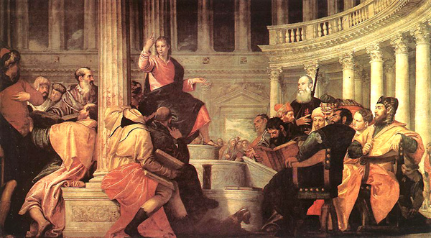Fifth Joyful Mystery – The Finding of the Child Jesus in the Temple – “After three days they found Him in the temple, sitting in the midst of the teachers, listening to them and asking them questions…And He returned with His parents to Nazareth, and was obedient to them.” (Luke 2:46, 51)

The Sorrowful Mysteries are said on
Tuesday and Friday
The Gospels give great prominence to the Sorrowful Mysteries of Christ. From the beginning, Christian piety, especially during the Lenten devotion of the Way of the Cross, has focused on the individual moments of the Passion, realizing that here is found the culmination of the revelation of God’s love and the source of our salvation.

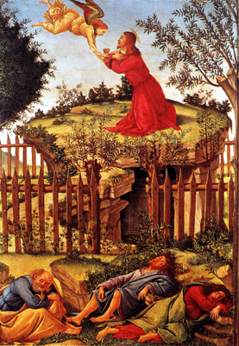First Sorrowful Mystery – The Agony in the Garden – Kneeling down, he began to pray, “Father if it be Your will, take this cup from me, yet not my will but Yours be done…In His anguish he prayed even more intensely, and His sweat became like drops of blood falling to the ground.” (Luke 22:42, 44)

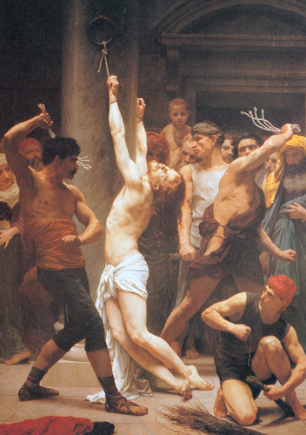Second Sorrowful Mystery – The Scourging at the Pillar – Pilate released Barabbas to them. Jesus, however, he first had scourged; then he handed Him over to be crucified. (Matthew 27:26)

Third Sorrowful Mystery – The Crowning with Thorns – Weaving a crown of thorns they fixed it on His head, and placed a reed in his right hand. To make fun of him they knelt before him saying: “Hail King of the Jews.” They spat on Him, and took the reed and kept striking him on the head. (Matthew 27:29, 30)

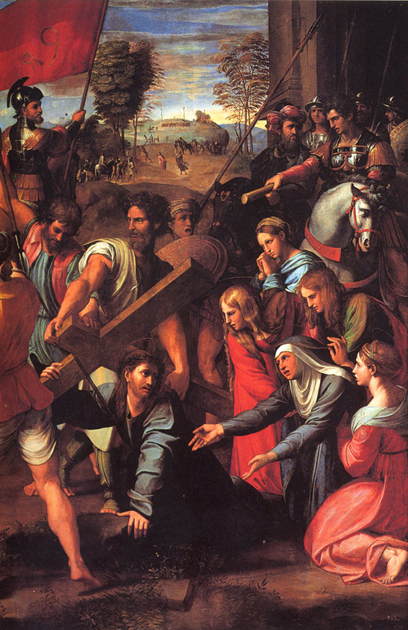Fourth Sorrowful Mystery – The Carrying of the Cross – When the soldiers had finished mocking Him,…they led Him away to crucify Him. On the way they laid hold of a certain Simon of Cyrene, coming from the country, and upon Him they laid the cross to bear it after Jesus. (Matthew 27:31; Luke 23:26)
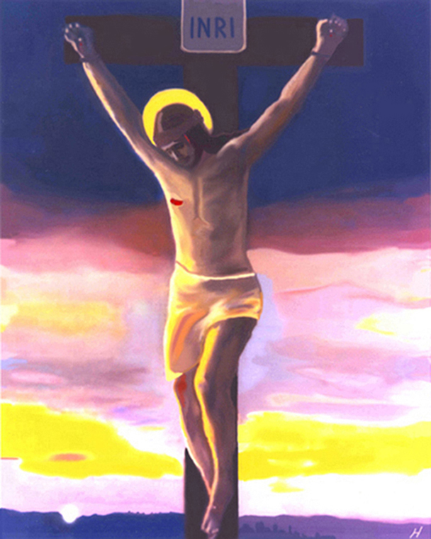Fifth Sorrowful Mystery – The Crucifixion – When they came to the place called the Skull, they crucified Him…Jesus said, “Father, forgive them, for they do not know what they are doing”…There was darkness over the whole land until the ninth hour…and Jesus cried out with a loud voice, “Father, into Your hands I commend my spirit.” (Luke 23:33, 34, 44, 46)

The Glorious Mysteries are said on
Wednesday and Sunday
(With these exceptions: Sundays of Christmas season – the Joyful; Sundays of Lent – the Sorrowful).
“The contemplation of Christ’s face cannot stop at the image of the Crucified One, He is the Risen One!” The Rosary has always expressed this knowledge born of faith and invited the believer to pass beyond the darkness of the Passion in order to gaze upon Christ’s glory in the Resurrection and Ascension. Mary herself would be raised to that same glory in the Assumption.

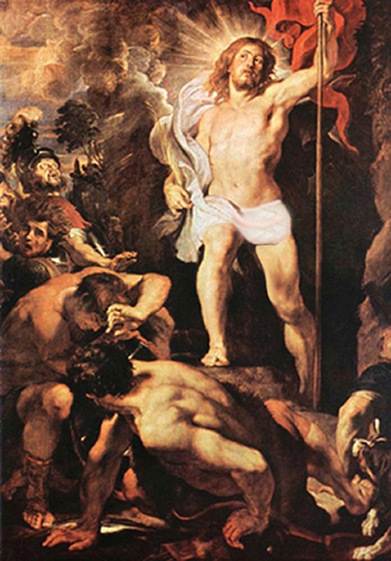First Glorious Mystery – The Resurrection – And looking up they saw that the stone had been rolled back, for it was very large…On entering the tomb they saw a Young man sitting at the right side who said to them, “Do not be afraid, You are looking for Jesus of Nazareth who was crucified. He is risen, He is not here. Behold the place where they laid Him.” (Mark 16:4-6)

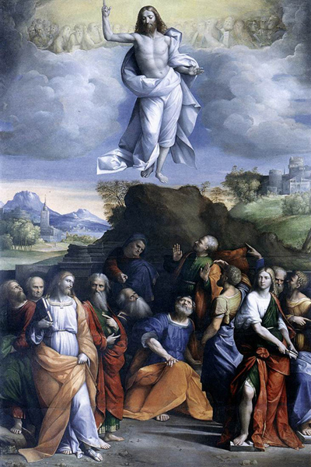Second Glorious Mystery – The Ascension – “Then, after speaking to them, the Lord Jesus was taken up into heaven and took His seat at God’s right hand.” (Mark 16:19)

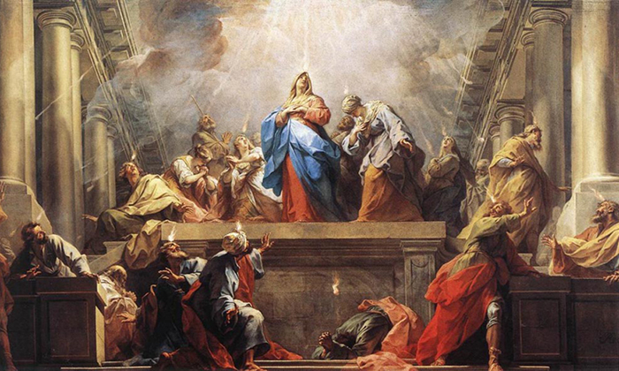Third Glorious Mystery – The Descent of the Holy Spirit – “And there appeared to them parted tongues as of fire, which settled upon each of them. And they were filled with the Holy Spirit and began to speak in foreign tongues, even as the Holy Spirit prompted them to speak.” (Acts 2:3, 4)

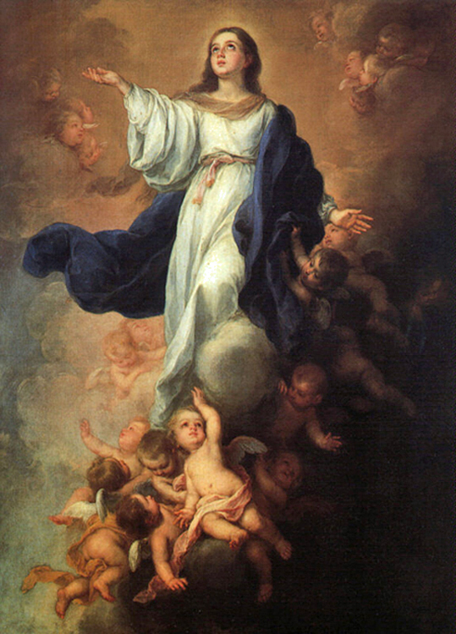Fourth Glorious Mystery – The Assumption – Arise, my beloved, my beautiful one, and come!...You are all beautiful, my beloved, and there is no blemish in You. (Sg. 2:10; 4:7) You are the glory of Jerusalem…You are the splendid boast of our people. (Jdt 15:9)
Fifth Glorious Mystery – The Coronation – A great sign appeared in the sky, a woman clothed with the sun, with the moon under her feet, and on her head a crown of twelve stars. (Revelation 12:1)

The Luminous Mysteries are said on Thursday
Moving on from the infancy and the hidden life in Nazareth to the public life of Jesus, our contemplation brings us to those mysteries which may be called in a special way “Mysteries of Light.” Certainly, the whole mystery of Christ is a mystery of light. He is the “Light of the world” (John 8:12). Yet this truth emerges in a special way during the years of His public life.

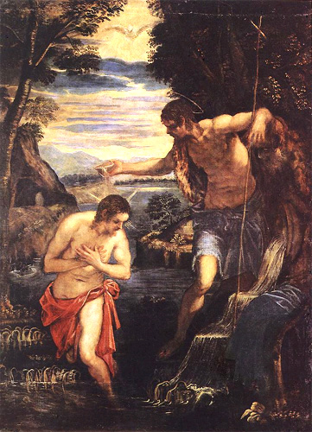First Luminous Mystery – Baptism of Jesus – And when Jesus was baptized…the heavens were opened and He saw the Spirit of God descending like a dove, and alighting on Him, and lo, a voice from heaven, saying “this is My beloved Son, with whom I am well pleased.” (Matthew 3:16-17)
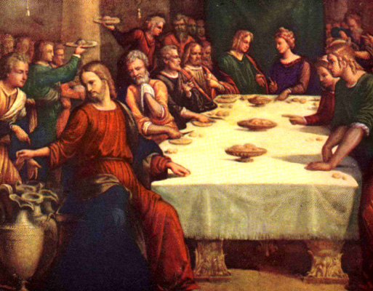Second Luminous Mystery – Wedding at Cana – His mother said to the servants, “Do whatever He tells You”…Jesus said to them, “Fill the jars with water.” And they filled them up to the brim. (John 2:5-7)

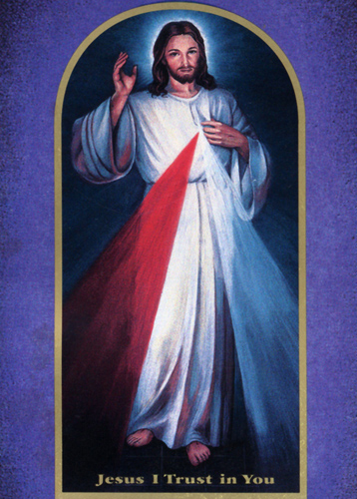Third Luminous Mystery – Proclaiming the Kingdom – “And preach as You go, saying, “The kingdom of heaven is at hand.” Heal the sick, raise the dead, cleanse the lepers, cast out demons. You received without pay, give without pay.” (Matthew 10:7-8)

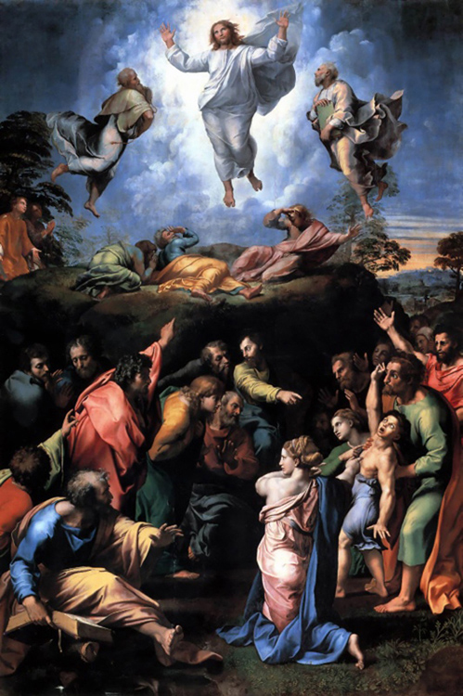Fourth Luminous Mystery – Transfiguration – And as He was praying, the appearance of His countenance was altered and His raiment became dazzling white. And a voice came out of the cloud saying, “This is My Son, My chosen; listen to Him!” (Luke 9:29, 35)

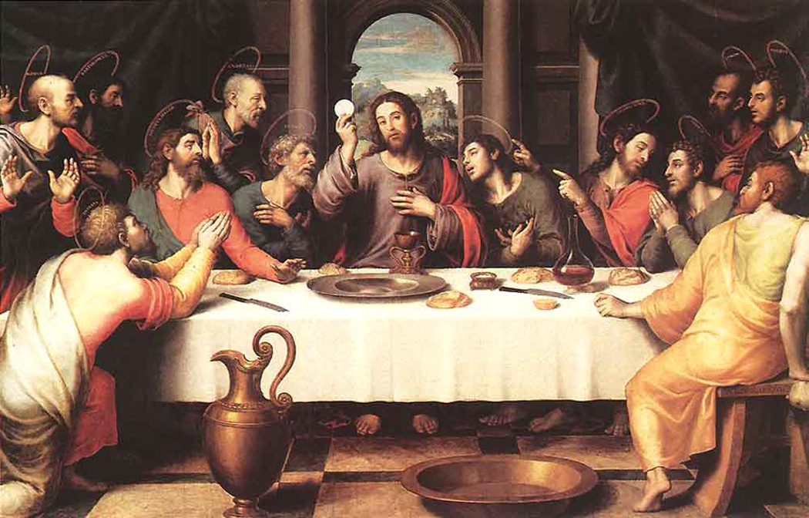Fifth Luminous Mystery – Institution of the Eucharist – And He took bread, and when He had given thanks He broke it and gave it to them, saying, “This is My body which is given for You.”…And likewise the cup after supper, saying, “This cup which is poured out for You is the new covenant in My blood.” (Luke 22:19-20)

After each decade say the following prayer requested by the Blessed Virgin Mary at Fatima:
“O my Jesus, forgive us our sins, save us
from the fires of hell, lead all souls to
Heaven, especially those who have most
need of Your mercy.”

Rosary of the Seven Sorrows
This devotion was originated in the Thirteenth century. It recalls the Sorrows the Virgin Mother of God endured in compassion for the suffering and death of her Divine Son. The Seven Sorrows rosary consists of seven Hail Marys for each of the seven Sorrows. One Our Father is said before each group of seven Hail Marys which are separated by a medal. On the three beads of the rosary at the end, three Hail Marys are said in honor of the Tears of our Sorrowful Mother. While reciting the prayers meditate upon:

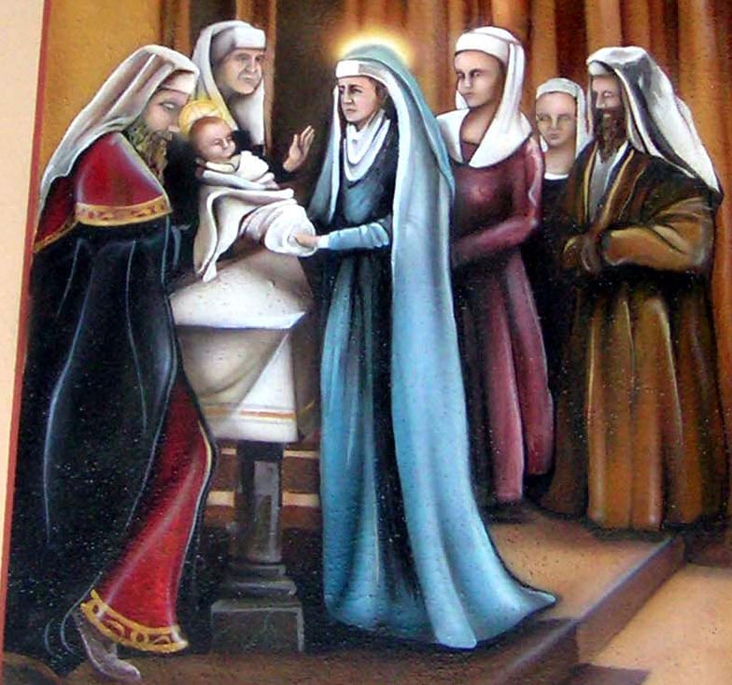The First Sorrow – The Prophecy -
The prophecy of holy Simeon who told Our Sorrowful Mother of the bitter passion and death of Jesus. (Our Father – Seven Hail Marys)
The Second Sorrow – The Flight -
Our Sorrowful Mother is forced to flee into Egypt to save her beloved Son from the death decreed by Herod. (Our Father – Seven Hail Marys)

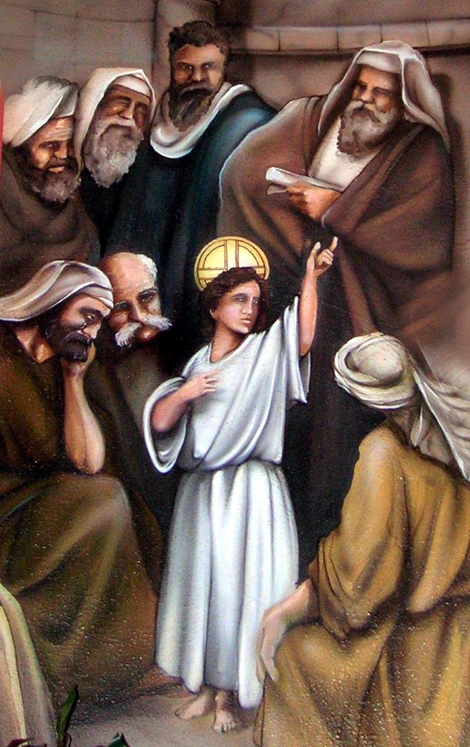The Third Sorrow – The Loss -
Our Sorrowful Mother is separated from Jesus for three long days while He is lost in Jerusalem. (Our Father – Seven Hail Marys)

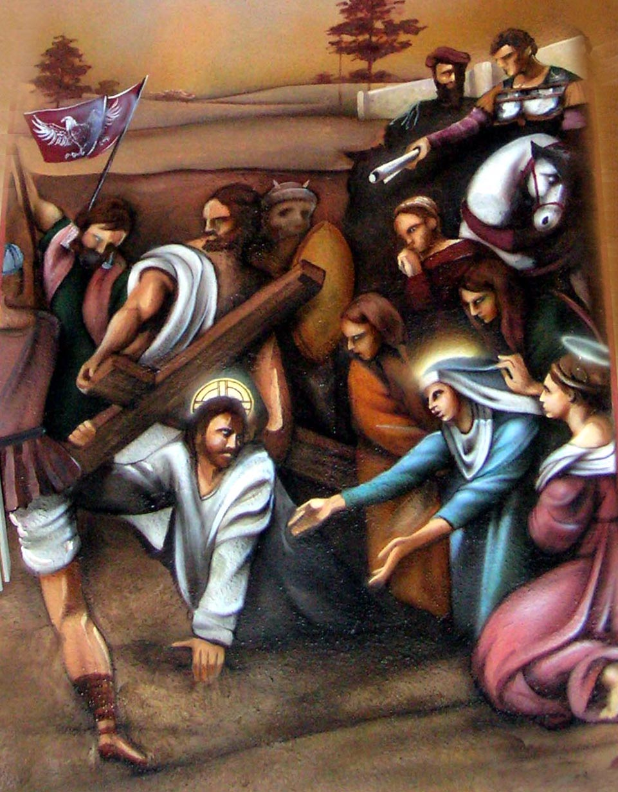The Fourth Sorrow – The Meeting -
Our Sorrowful Mother meets Jesus on the road to Calvary and sees Him fall under the cruel weight of the cross. (Our Father – Seven Hail Marys)

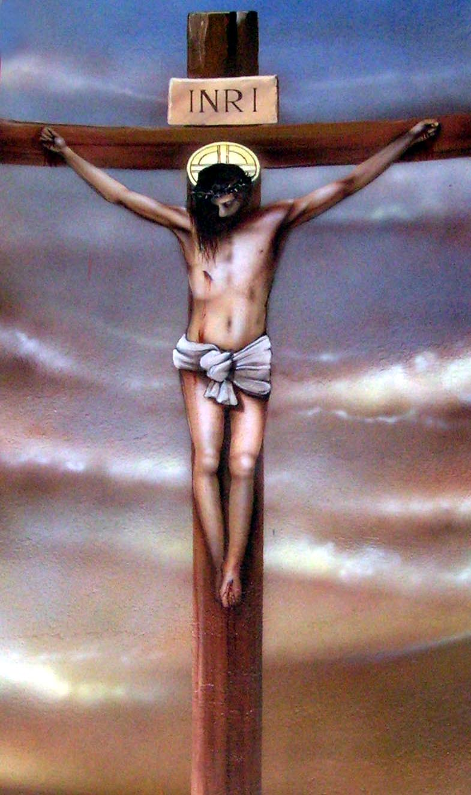The Fifth Sorrow – Jesus Dies -
Our Sorrowful Mother watches Jesus die on the Cross. (Our Father – Seven Hail Marys)
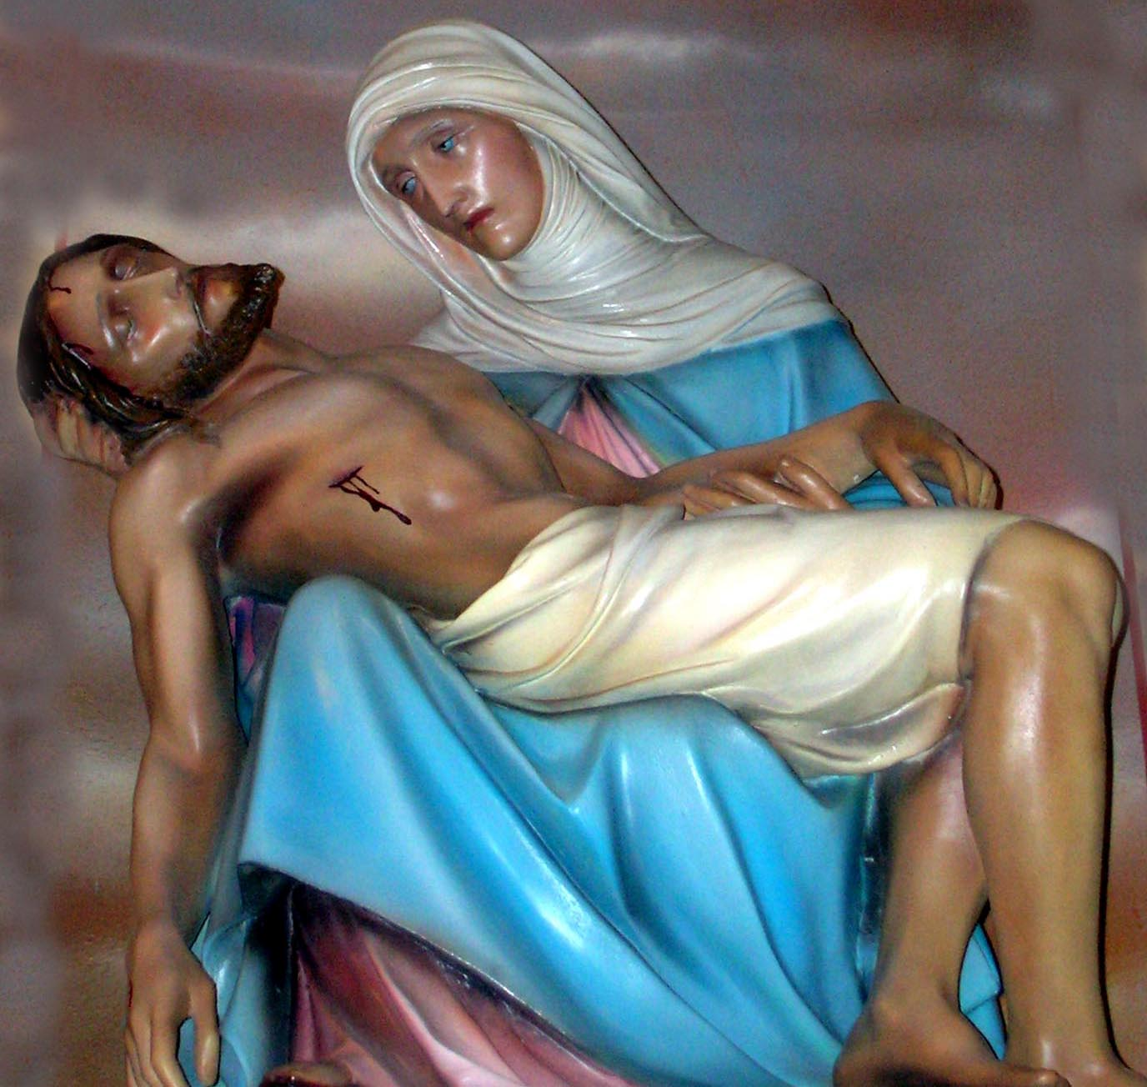The Sixth Sorrow – Mary Receives Jesus -
Our Sorrowful Mother receives the dead body of Jesus in her arms. (Our Father – Seven Hail Marys)

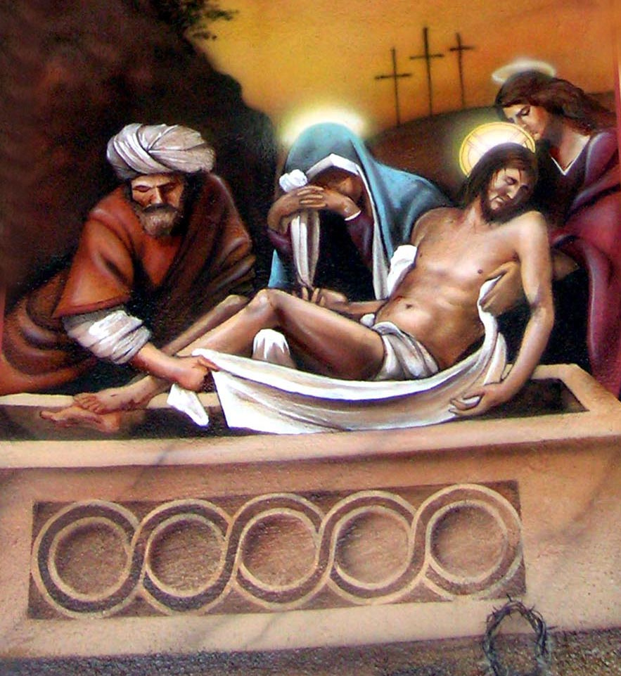The Seventh Sorrow – The Burial -
Our Sorrowful Mother sees Jesus placed in the sacred tomb. (Our Father – Seven Hair Marys)
Three Hail Marys
Three Hail Marys are said in honor of
The Tears of Our Sorrowful Mother.

(Our Father, Hail Mary, Glory Be)
For the intention of the Pope.

Chaplet of Divine Mercy
(On ordinary rosary beads)
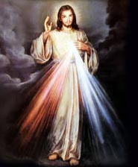
Optional Opening Prayer
You expired, Jesus, but the source of life gushed forth for souls, and the ocean of mercy opened up for the whole world. O Fount of Life, unfathomable Divine Mercy, envelop the whole world and empty Yourself out upon us.

O Blood and Water, which gushed forth from the Heart of Jesus as a fountain of Mercy for us, I trust in You!
Begin with:
Our Father, Who art in heaven, hallowed be Thy name; Thy kingdom come; Thy will be done on earth as it is in heaven. Give us this day our daily bread and forgive us our trespasses as we forgive those who trespass against us; and lead us not into temptation, but deliver us from evil. Amen.
Hail Mary, full of grace. The Lord is with Thee. Blessed art Thou among women, and blessed is the fruit of Thy womb, Jesus. Holy Mary, Mother of God, pray for us sinners, now and at the hour of our death. Amen.

I believe in God the Father almighty, creator of heaven and earth. I believe in Jesus Christ, His only Son, our Lord. He was conceived by the power of the Holy Spirit, and born of the Virgin Mary. He suffered under Pontius Pilate, was crucified, died, and was buried. He descended to the dead. On the third day He rose again. He ascended into heaven, and is seated at the right hand of the Father. He will come again to judge the living and the dead.

I believe in the Holy Spirit, the holy Catholic Church, the communion of saints, the forgiveness of sins, the resurrection of the body, and life everlasting. Amen.

On the large bead before each decade:
Eternal Father, I offer You the Body and Blood, Soul and Divinity of Your dearly beloved Son, Our Lord Jesus Christ, in atonement for our sins and those of the whole world.

On the 10 small beads of each decade:
For the sake of His sorrowful Passion, have mercy on us and on the whole world.

Conclude with: (after five decades)
Holy God, Holy Mighty One, Holy Immortal One, have mercy on us and on the whole world (3 times).

Teenage Prayer

Almighty God and Father, the more I learn about this universe that You have created, the more I marvel at Your greatness. I thank You for giving me life and making me part of it all. I thank You also for giving me an intelligence and free-will that make me responsible for my own destiny. Yet this responsibility awes me and makes me uneasy for I am afraid that I may use these gifts unwisely and bring about my own unhappiness causing me to be unworthy of Your love. Help me to use my intelligence to distinguish good from bad. Enlighten my mind that I may see through the false ideas and standards that continually try to mislead me, especially the false picture of life too often shown on television, the movies and in books.

Strengthen my will that I may choose what is right and make me able to resist peer pressure so that I can be my own person and not just a weak follower.

Alert me to the dangers of sex, alcohol and drugs. Give me strength to study, work and develop my talents so that I may enjoy more fully the good life You have given me.
Guide me in choosing my friends so that we may enjoy life together. Bless my parents and family so that we may share a happy home life and may my growing in maturity and independence be achieved without too much friction and misunderstanding.

My loving Creator, keep me always close to You and may I come to understand that my Church is my best means of establishing a closer and deepening relationship with You.

Forgive me if through weakness or thoughtlessness I have disappointed You. Help me to be stronger in the future. I ask all this through Your son Jesus Christ, my Savior. Amen.

Prayer for Priests and Seminarians
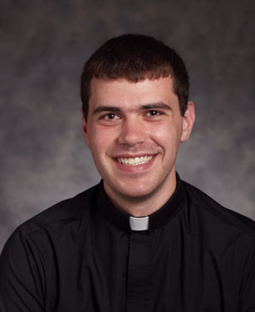
Good and Gentle Shepherd, we pray for all those you have called to serve in your Holy Priesthood. May they feed your flock by word, sacrament and deed driven by fervent prayer and a single-minded desire to serve you above all things. May they celebrate the Holy Sacrifice of the Mass with reverence, preach your Word with courage and be sober examples of resistance to the temptations of the devil. We also pray for our seminarians. May they study the Holy Scriptures and teachings of Your Church with respect and commitment. May generous souls provide for their needs and may they have no regret of leaving behind the things of this world for the things of your Holy Kingdom. Amen.

Emmaus Prayer for Priests

Lord Jesus, hear our prayer
For the spiritual renewal of priests.
We praise You for giving their ministry to the Church.
In these days renew them with the gifts of Your Spirit.
You once opened the Scriptures
To the disciples on the road to Emmaus.

Now renew Your ordained ministers
With the truth and power of Your Word.
In the Eucharist You gave the Emmaus disciples
Renewed life and hope.
Nourish priests with Your own Body and Blood.
Help them to imitate in their lives
The death and resurrection they celebrate at Your altar.

Give priests enthusiasm for the Gospel,
Zeal for the salvation of all,
Courage in leadership, humility in service,
Fellowship with one another and with all their brothers and sisters in You.
For You love them, Lord Jesus,
And we love and pray for them in Your name. Amen.

Prayer for Vocations

Heavenly Father, bless your Church with an abundance of holy and zealous priests, deacons, brothers and sisters. Give to those you have called to the married state and those you have chosen to live as single persons in this world, the special graces that their lives require. Form us all in the likeness of Your son so that in him, with him and through him, we may love you more deeply and serve you more faithfully, always and everywhere. With Mary we ask this through Christ, our Lord. Amen.

Parents Prayer for Vocations

Gracious and loving God
you have blessed us with the privilege of becoming Parents.
We ask that you provide us with all that we need
in accepting this awesome responsibility.

We pray that we will be open to your spirit
who is our source of strength
as we witness to our children
your love for each of them and your desire for them
to be happy and to live a full life.

We ask your help
so we may guide and encourage our children
to believe that they each have a special calling
and to use their gifts and talents for others.

We pray, Heavenly Father,
that our children will discover
and respond enthusiastically to your desire for them
whether it be to the vocation of single, married, ordained or consecrated life.

We offer this prayer in the name of Jesus
through the grace of the Holy Spirit. Amen.

For Youth and for Vocations
O Lord, who said to Your apostles, “Suffer little children to come unto me,” how much Your paternal heart must suffer to see the efforts of the impious to wrench from You the souls of these little ones. Have pity on these poor souls; be pleased to multiply the number of Christian teachers entrusted with directing them on the right road. Send laborers into Your vineyard, fill them with Your Spirit, make their labors fruitful, and preserve the fruits thereof, we beg You through Your Sacred Heart. Immaculate heart of Mary, preserve the purity of these children’s hearts.

Saint Joseph, patron of the universal Church, inspire many a capable young man with the desire to consecrate himself to that most excellent work: the Christian education of Youth. Amen.

Prayer to St. Jude
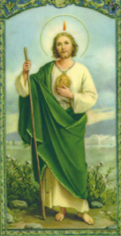
Saint Jude, glorious apostle, faithful servant and friend of Jesus, the name of the traitor has caused You to be forgotten by many. But the Church honors and invokes You universally as the patron of difficult and desperate cases. Pray for me who am so miserable. Make use, I implore You, of that particular privilege accorded to You to bring visible and speedy help where help was despaired of. Come to my assistance in this great need that I may receive the consolation and help of heaven in all my necessities, tribulations and sufferings, particularly – (here mention Your request) – and that I may bless God with You and all the elect throughout all eternity.
I promise You, O blessed Jude, to be ever mindful of this great favor, and I will never cease to honor You as my special and powerful patron and do all in my power to encourage devotion to You. Amen.

Prayer for a Happy Death
Oh, my Lord and Savior, support me in that hour in the strong arms of Your sacraments, and by the fresh fragrance of Your consolations. Let the absolving words be said over me, and the holy oil sign and seal me, and Your own Body be my food, and Your Blood my sprinkling; and let my sweet Mother Mary breathe on me, and my Angel whisper peace to me, and my glorious Saints, smile upon me; that in them all, and through them all, I may receive the gift of perseverance, and die as I desire to live, in Your faith, in Your Church, in Your service, and in Your love. Amen.

Litany of the Sacred Heart of Jesus
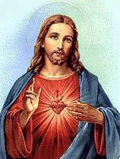
Lord, have mercy on us.
Christ, have mercy on us.
Lord, have mercy on us.
Christ, hear us.
Christ, graciously hear us.
God the Father of heaven, have mercy on us.
God the Son, Redeemer of the world, have mercy on us.
God the Holy Spirit, have mercy on us.
Holy Trinity, one God, have mercy on us.

Heart of Jesus, Son of the Eternal Father,
Heart of Jesus, formed by the Holy Spirit in the womb of the Virgin Mother,
Heart of Jesus, united substantially with the Word of God,
Heart of Jesus, of infinite majesty,
Heart of Jesus, holy temple of God,
Heart of Jesus, tabernacle of the Most High,
Heart of Jesus, house of God and gate of heaven,
Heart of Jesus, glowing furnace of charity,
Heart of Jesus, vessel of justice and love,
Heart of Jesus, full of goodness and love,
Heart of Jesus, abyss of all virtues,
Heart of Jesus, most worthy of all praise,
Heart of Jesus, king and center of all hearts,
Heart of Jesus, in whom are all the treasures of wisdom and knowledge,
Heart of Jesus, in whom the Father is well pleased,
Heart of Jesus, of whose fullness we have all received,
Heart of Jesus, desire of the eternal hills,
Heart of Jesus, patient and rich in mercy,
Heart of Jesus, rich to all who invoke You,
Heart of Jesus, fount of life and holiness,
Heart of Jesus, propitiation for our sins,
Heart of Jesus, loaded down with opprobrium,
Heart of Jesus, bruised for our offenses,
Heart of Jesus, made obedient unto death,
Heart of Jesus, pierced with a lance,
Heart of Jesus, source of all consolation,
Heart of Jesus, our life and resurrection,
Heart of Jesus, our peace and reconciliation,
Heart of Jesus, victim for our sin,
Heart of Jesus, salvation of those who hope in You,
Heart of Jesus, hope of those who die in You,
Heart of Jesus, delight of all saints.

Lamb of God, You take away the sins of the world, spare us O Lord.
Lamb of God, You take away the sins of the world, graciously hear us, O Lord.
Lamb of God, You take away the sins of the world, have mercy on us.

V. Jesus, gentle and humble of heart,
R. Make our hearts like to Yours.

LET US PRAY: Almighty and everlasting God, graciously regard the Heart of Your well-beloved Son and the acts of praise and satisfaction which he renders You on behalf of us sinners; and through their merit, grant pardon to us who implore Your mercy; in the name of your Son Jesus Christ, who lives and reigns with You in the unity of the Holy Spirit, world without end. Amen.

Litany of the Blessed Virgin

Lord, have mercy on us.
Christ, have mercy on us.
Lord, have mercy on us.
Christ, hear us.
Christ, graciously hear us.
God the Father of Heaven, have mercy on us.
God, the Son, Redeemer of the world, have mercy on us.
God, the Holy Spirit, have mercy on us.
Holy Trinity, one God, have mercy on us.
Holy Mary, pray for us.
Holy Mother of God, pray for us
Holy Virgin of virgins,
Mother of Christ,
Mother of divine grace,
Mother most pure,
Mother most chaste,
Mother inviolate,
Mother most amiable,
Mother most admirable,
Mother of good counsel,
Mother of our Creator,
Mother of our Savior,
Virgin most prudent,
Virgin most venerable,
Virgin most renowned,
Virgin more powerful,
Virgin most merciful,
Virgin most faithful,
Mirror of justice,
Seat of wisdom,
Cause of our joy,
Spiritual vessel,
Vessel of honor,
Mystical rose,
Tower of David,
Tower of ivory,
House of gold,
Ark of the covenant,
Gate of heaven,
Morning star,
Health of the sick,
Refuge of sinners,
Comforter of the afflicted,
Help of Christians,
Queen of angels,
Queen of Patriarchs,
Queen of Prophets,
Queen of Apostles,
Queen of Martyrs,
Queen of Confessors,
Queen of Virgins,
Queen of all Saints,
Queen conceived without original sin,
Queen assumed into heaven,
Queen of the most holy rosary,
Queen of peace.

Lamb of God, You take away the sins of the world, spare us, O Lord.
Lamb of God, You take away the sins of the world, graciously hear us, O Lord.
Lamb of God, You take away the sins of the world, have mercy on us.

V. Pray for us, O holy Mother of God.
- That we may be made worthy of the promises of Christ.
LET US PRAY Grant, we beseech You, O Lord God, that we, Your servants, may enjoy perpetual health of soul and body; and by the glorious intercession of Blessed Mary, ever Virgin, may be delivered from present sorrows and rejoice in eternal happiness. Through Christ, our Lord. Amen.

Litany of St. Joseph
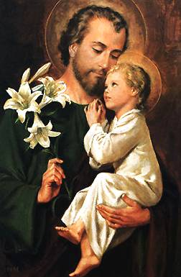
Lord, have mercy on us.
Christ, have mercy on us.
Lord, have mercy on us.
Christ, hear us.
Christ, graciously hear us.
God the Father of heaven, have mercy on us.
God the Son, Redeemer of the world, have mercy on us.
God the Holy Spirit, have mercy on us.
Holy Trinity, one God, have mercy on us.
Holy Mary, Pray for us.
Saint Joseph, Illustrious Son of David,
Splendor of patriarchs,
Spouse of the Mother of God,
Chaste Guardian of the Virgin,
Foster-Father of the Son of God,
Watchful Defender of Christ,
Head of the Holy Family,
Joseph most just,
Joseph most pure,
Joseph most prudent,
Joseph most courageous,
Joseph most obedient,
Joseph most faithful,
Mirror of patience,
Lover of poverty,
Model of all who labor,
Glory of family life,
Preserver of virgins,
Mainstay of families,
Solace of the afflicted,
Hope of the sick,
Patron of the dying,
Terror of demons,
Protector of Holy Church.
Lamb of God, who takes away the sins of the world, Spare us, O Lord.
Lamb of God, who takes away the sins of the world, graciously hear us, O Lord.
Lamb of God, who takes away the sins of the world, have mercy on us.

LET US PRAY. O God, who in You ineffable providence did vouchsafe to choose blessed Joseph to be the spouse of Thy most holy Mother, grant, we beseech You, that we may be worthy to have him for our intercessor in heaven whom on earth we venerate as our protector; who lives and reigns world without end. Amen.

Prayer to Prepare for Mass
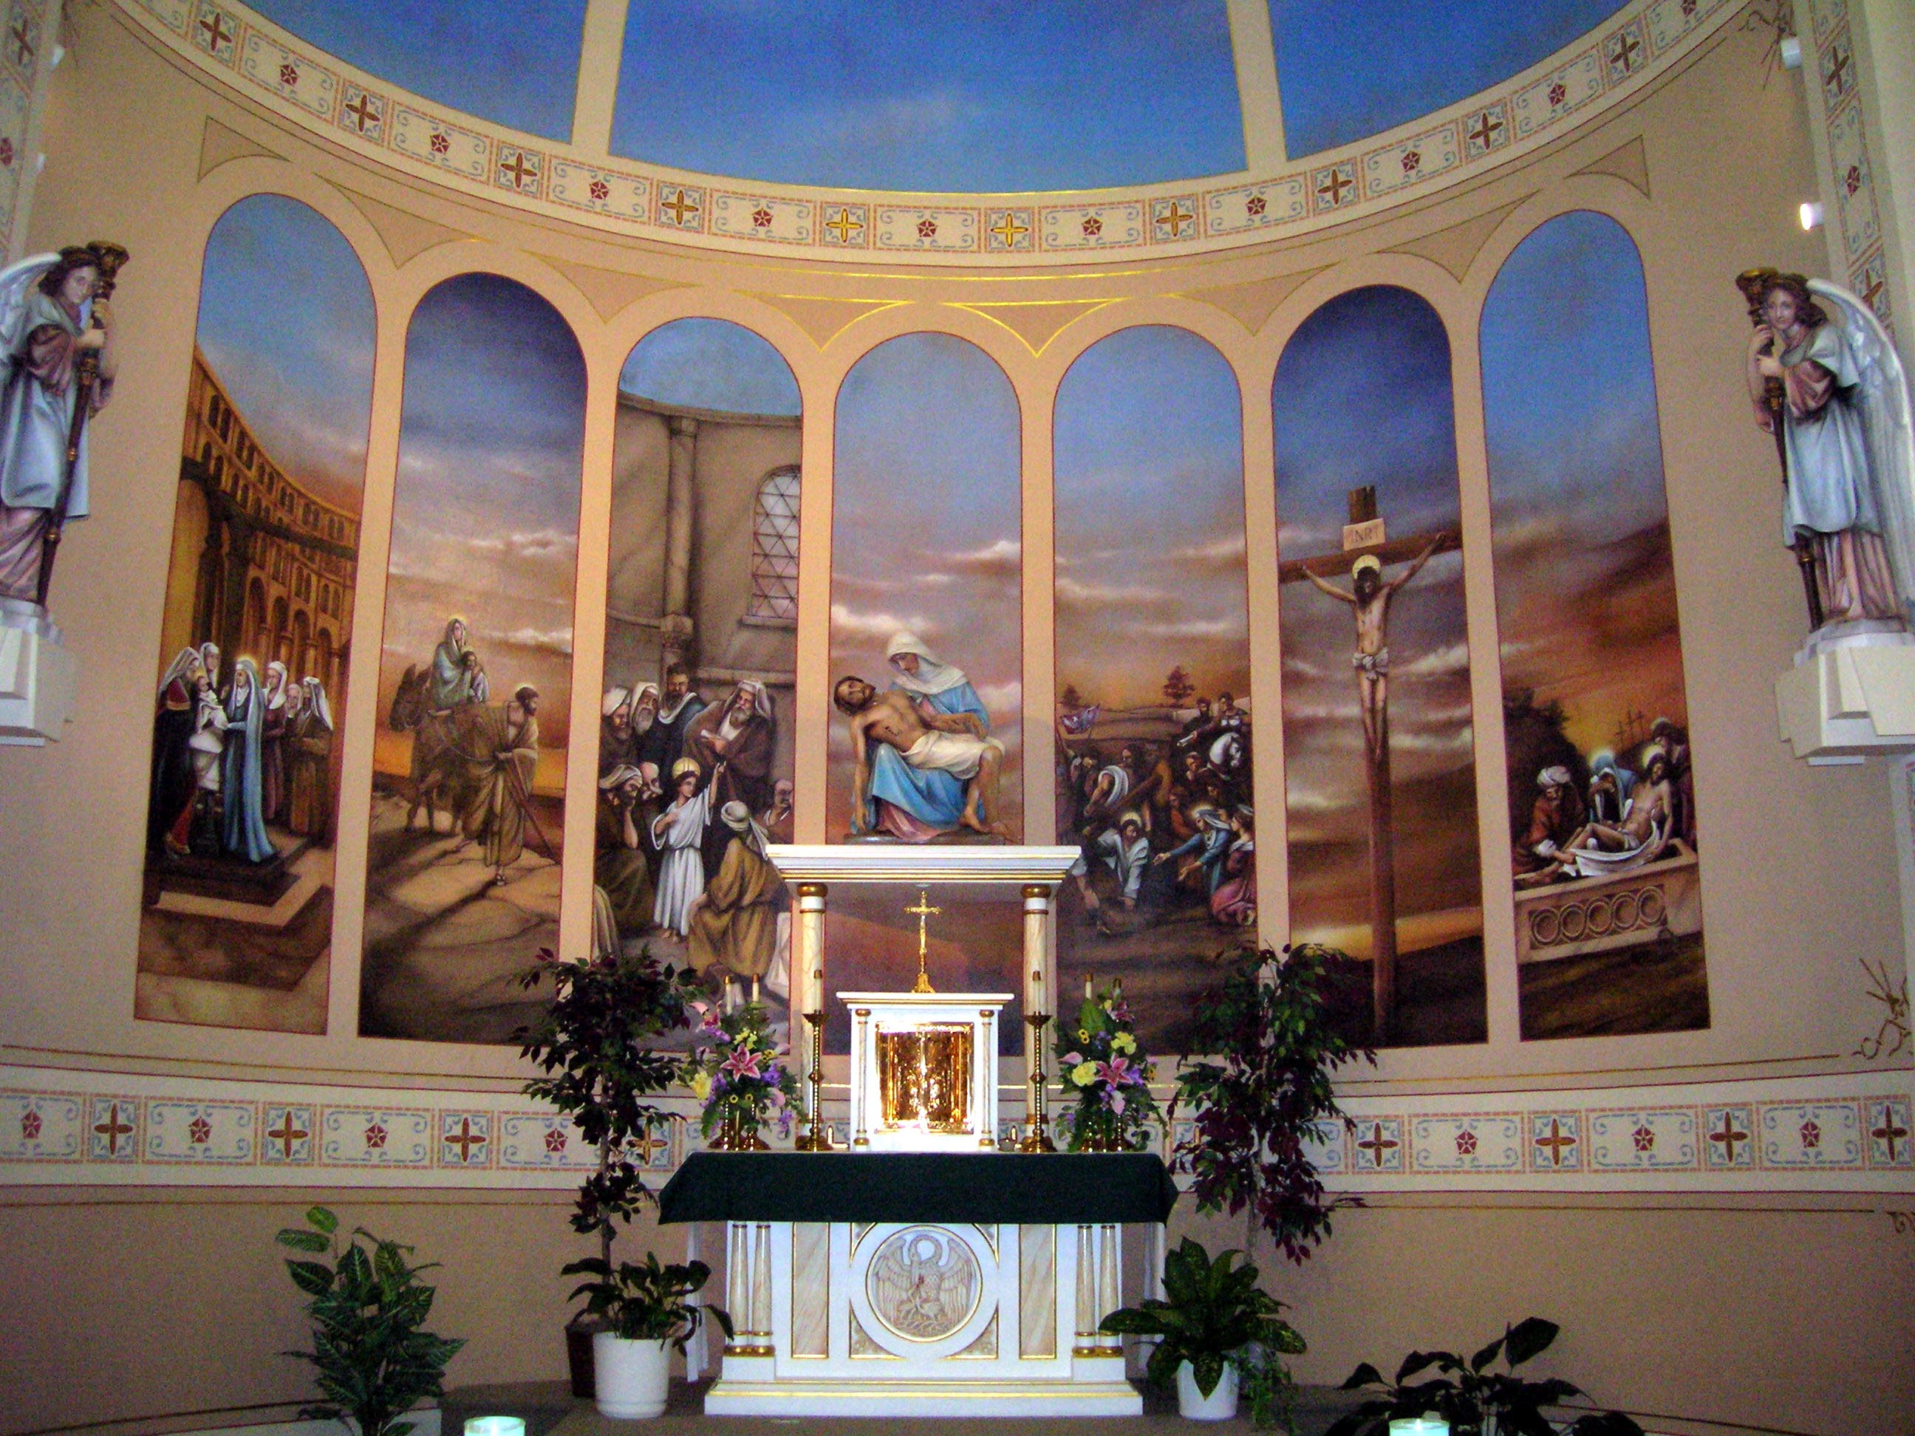
God of all, I come into your house and present myself to you sorry for the sins in my mind and heart. Allow me in the calmness of this place to be ever conscious that you are present here. Please transform me into that generous and loving soul which that you want me to be. May I receive your precious Body and Blood worthily and leave here prepared to love others as you have loved me, even unto the Holy Cross. I pray this through Christ our Lord. Amen.

Short Preparation for Mass
Act of Faith. O God, because You have said it, I believe that I shall receive the Sacred Body of Jesus Christ to eat, and his Precious Blood to drink. My God, I believe this with all my heart.

Act of Humility. My God, I confess that I am a poor sinner; I am not worthy to receive the Body and Blood of Jesus, on account of my sins. Lord, I am not worthy to receive You under my roof; but only say the word, and my soul will be healed.

Act of Sorrow. My God, I detest all the sins of my life. I am sorry for them, because they have offended You, my God, who are so good. I resolve never to commit sin anymore. My good God, pity me, have mercy on me, forgive me.

Act of Adoration. O Jesus, great God, present on the Altar, I bow down before You, I adore You.

Act of Love and Desire. Jesus, I love You. I desire with all my heart to receive You. Jesus, come into my poor soul, and give me Your Flesh to eat and Your Blood to drink. Give me You whole Self, Body, Blood, Soul and Divinity, that I may live for ever with You.

Short Thanksgiving after Holy Communion
Act of Faith. O Jesus, I believe that I have received Your Flesh to eat and Your Blood to drink, because You have said it, and Your word is true. All that I have and all that I am are Your gift and now You have given me Yourself.

Act of Adoration. O Jesus, my God, my Creator, I adore You, because from Your hands I came and with You I am to be happy for ever.

Act of Humility. O Jesus, I am not worthy to receive You, and yet You have come to me that my poor heart may learn of You to be gentle and humble.

Act of Love. Jesus, I love You. I love you with all my heart. You know that I love You, and wish to love You daily more and more.
Act of Thanksgiving. My good Jesus, I thank You with all my heart. How good, how kind You are to me. Blessed Jesus in the most holy Sacrament of the Altar.

Act of Offering. O Jesus, receive my poor offering. Jesus You have given Yourself to me, and now let me give myself to You I give You my body, that it may be chaste and pure. I give you my soul, that it may be free from sin. I give You my heart, that it may always love You. I give You every breath that I shall breathe, and especially my last, I give You myself in life and in death, that I may be Yours forever and ever. Remember the words of Jesus, “Ask and You shall receive.”

Prayer for Others
O Jesus, have mercy on Your holy Church; take care of it.
O Jesus, have pity on poor sinners, and save them from hell.
O Jesus, bless my father, my mother, my brothers and sisters, and all I ought to pray for, as Your Heart knows how to bless them.
O Jesus, have pity on the poor souls in purgatory and give them eternal rest.

Prayer for Yourself
O Jesus, wash away my sins with Your Precious Blood.
O Jesus, the struggle against temptation is not yet finished. My Jesus, when temptation comes near me, make me strong against it. In the moment of temptation may I always say: “My Jesus mercy! Mary, help!”

O Jesus, may I lead a good life; may I die a happy death. May I receive You before I die. May I say when I am dying: “Jesus, Mary and Joseph, I give You my heart and my soul.”

Listen now for a moment to Jesus Christ; perhaps He has something to say to You. Answer Jesus in Your heart; and tell him all Your troubles. Then say:

Jesus, I am going away for a time, but I trust not without You. You are with me by Your grace. I resolve never to leave You by mortal sin. Although I am so weak I have such hope in You. Give me grace to persevere.

Long Preparation for Mass
(Prayer of St. Thomas Aquinas)
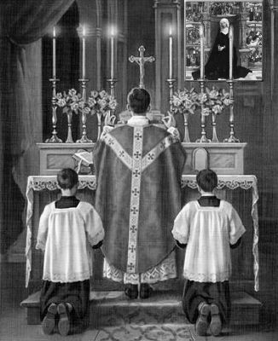
Almighty and everlasting God I approach the sacrament of Your only-begotten Son, our Lord Jesus Christ. I come as a sick person to the physician who will save his life, as someone unclean to the springs of mercy, as a blind man to the brightness of eternal light, and as someone poor and needy to the Master of heaven and earth. I ask You, from Your abundance and Your generosity, to heal my sickness, to wash away my impurity, to light up my blindness, enrich my emptiness and clothe my nakedness. I want to receive the bread of angels, the King of kings and Lord of lords, with reverence and humility, with sorrow for my sins and devotion, with a pure intention and faith, with conviction and meaning. For then it will be good for the health of my soul. May I receive not only the sacrament itself, but also its inner power and deep effects. O gentlest Lord, grant that by receiving His body which He took from the Virgin Mary, I may be grafted onto his Mystical Body and become one of His members. O most loving Father, I am about to receive the person of Your beloved Son disguised as bread; may I look on him one day undisguised, face to face. You live and reign with Your Son and the Holy Spirit, one God, for ever and ever. Amen.

Prayer of St. Ambrose
Christ Jesus, good Lord,
I approach the table of Your rich and filling banquet
with feelings of reverence and fear,
for even though I am a sinner and unable to rely on my own merits, yet I trust in Your mercy and goodness.
I have sinned to heart and body many times.
I have not kept guard over my mind and tongue.
So, kind God, awesome in majesty, source of mercy,
I run to You with my emptiness and my anxieties hurrying to be healed, and seeking refuge under Your protection.
While I dare not face You as a judge,
I desire to have You as my savior.
Lord I am revealing my hurts to You and what makes me ashamed of myself.
I am conscious of my many sins; they cause me anxiety,
but I trust in Your boundless mercy.
Look on me with a forgiving glance, Lord Jesus,
Eternal King, God-man, crucified for us.
Listen to me for I hope in You.
Have pity on me for I am full of sadness and sin.
You are the spring of compassion which never stops flowing,
I offer You my morning greetings; You are my saving victim,
offered for me and the whole human race on the cross.
And I welcome You too, noble and precious blood,
flowing from the wounds of Jesus my Lord,
washing all the world.
Lord, remember me, Your creature, whom You have redeemed by Your blood.
I am sorry I have sinned;
I wish to make amends. Take away from me, generous Father,
all my sins so that with a clean mind and body
I may be able to receive the most Holy of Holy Things.
Grant that this communion in Your body and blood
which I am going to receive,
may wipe away my sins and cleanse me from their evil effects;
may it put to flight my bad thoughts and renew my good ones.
Let it empower me to do what is pleasing to You
And be a firm protection from harm of body and soul. Amen.

Thanksgiving After Mass and Communion
Canticle from Daniel
Bless the Lord, all You works of the Lord.
Praise and exalt Him above the Lord.
Angels of the Lord, bless the Lord.
You heavens, bless the Lord.
All You hosts of the Lord, bless the Lord.
Sun and moon, bless the Lord.
Stars and heaven, bless the Lord.

Every shower and dew, bless the Lord.
All You winds, bless the Lord.
Fire and heat, bless the Lord.
Cold and chill, bless the Lord.
Dew and rain, bless the Lord.
Frost and chill, bless the Lord.
Ice and snow, bless the Lord.
Nights and days, bless the Lord.
Light and darkness, bless the Lord.
Lightnings and clouds, bless the Lord.
Let the earth, bless the Lord.
Praise and exalt him above all forever.
Mountains and hill, bless the Lord.
Everything growing from the earth, bless the Lord.
You springs, bless the Lord.
You dolphins and all water creatures, bless the Lord.
All You birds of the air, bless the Lord.
All You beasts, wild and tame, bless the Lord.
You sons of men, bless the Lord.

O Israel, bless the Lord.
Praise and exalt Him above all forever.
Priests of the Lord, bless the Lord.
Servants of the Lord, bless the Lord.
Spirits and souls of the just, bless the Lord.
Holy men of humble heart, bless the Lord.
Hananiah, Azariah, Mishael, bless the Lord.
Praise and exalt Him above all forever.

Let us bless the Father, and the Son, and the Holy Spirit,
Let us praise and exalt him above all forever.
Blessed are You, Lord, in the firmament of heaven.
Praiseworthy and glorious and exalted above all forever.

Psalm 150
Praise God in His holy place,
praise Him in His mighty heavens.
Praise Him for his powerful deeds,
praise His surpassing greatness.
O praise Him with sound of trumpet,
praise Him with lute and harp.
Praise Him with timbrel and dance,
praise Him with strings and pipes.
O praise Him with resounding cymbals,
praise Him with clash of cymbals.
Let everything that lives and that breathes
give praise to the Lord.
Prayer of St. Thomas Aquinas
Holy Lord, Father almighty, I thank You for having fed me with the precious body and blood of Your Son, Jesus Christ our Lord. I have not deserved it for I am only Your sinful and unworthy servant; You have been merciful to me. I pray that this holy communion may bring about my pardon and salvation. Let it be my armor of faith and the shield of good will for me.
Let it purge away my vices, and kill off evil desires and lust. May it advance me in love and patience, in humility and obedience and other virtues. May this communion be a strong defense against the traps set by my enemies, the visible ones and the invisible ones, so that every disturbance of body and soul may be stilled, and that I may be bound firmly to You, my God. Only You can bring my last hour to a happy close, I pray also that in spite of my sinfulness You will lead me to that indescribably happy banquet in heaven. There You and Your Son and the Holy Spirit are for Your saints true light, complete fulfillment, everlasting joy, perfect gladness and uninterrupted happiness. Amen.

Prayer Before the Crucifix

My good and dearest Jesus, I kneel before You praying with all the intensity of my soul, that You engrave deep and vivid impressions of faith, hope and love upon my heart, a true sorrow for my sins, and a very firm resolve to make amends. At the same time, I meditate on Your five wounds, dwelling on them with deep compassion and grief. Good Jesus, I remember the words that the prophet David put into Your mouth when he wrote about You: They have pierced my hands and my feet; they have counted all my bones.

The Memorare
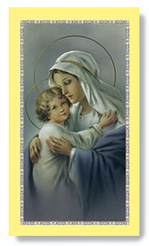
Remember, O most gracious virgin Mary, that never was it known that anyone who fled to thy protection, implored thy help and sought thy intercession was left unaided. Inspired with this confidence I fly to thee, O virgin of virgins, my mother. To thee I come, before thee I stand, sinful and sorrowful. O Mother of the Word Incarnate, despise not my petitions but in thy mercy hear and answer me. Amen.

Prayer for Peace
(Saint Francis of Assisi)
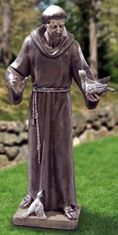
Lord, make me an instrument of Your peace. Where there is hatred, let me sow love. Where there is injury, pardon; where there is doubt, faith; where there is despair, hope; where there is darkness, light; where there is sadness, joy.

O divine Master, grant that I may seek not so much to be consoled as to console; to be understood as to understand; to be loved as to love. For it is in giving that we receive; it is in pardoning that we are pardoned; it is in dying that we are born to eternal life.

Campaign Prayer
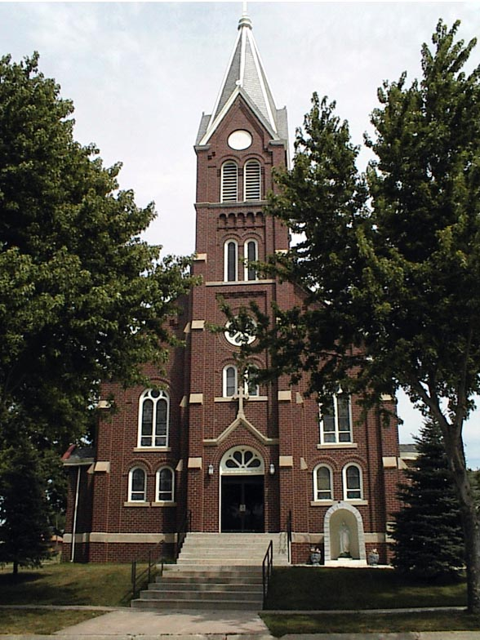
Oh Jesus, Lord and Savior, guide us and lead us in this new millennium as we strive to make our parish community more loving of one another and of You. Send your Holy Spirit to guide all of our deliberations and decisions. Help us make this house a place of beauty and calm where you offer peace and healing to all those who come with sincerity of heart. Reward those who support our parish church and school financially and through your grace make us a visible sign of the Kingdom of Heaven here on earth. Amen.

The Way of the Cross
This is a devotion to the Sacred Passion in which we accompany in spirit our Blessed Lord in His sorrowful journey from the house of Pilate to Calvary. We recall to mind all that took place from the time He was condemned to death to His being laid in the tomb. There are fourteen stopping places, or stations, in this Way of the Cross, at which something took place which it is well for us to call to mind and to think over. At each station we may say the Our Father and the Hail Mary, and think with love and sorrow for our sins, on the suffering of our Lord represented to us at the station.

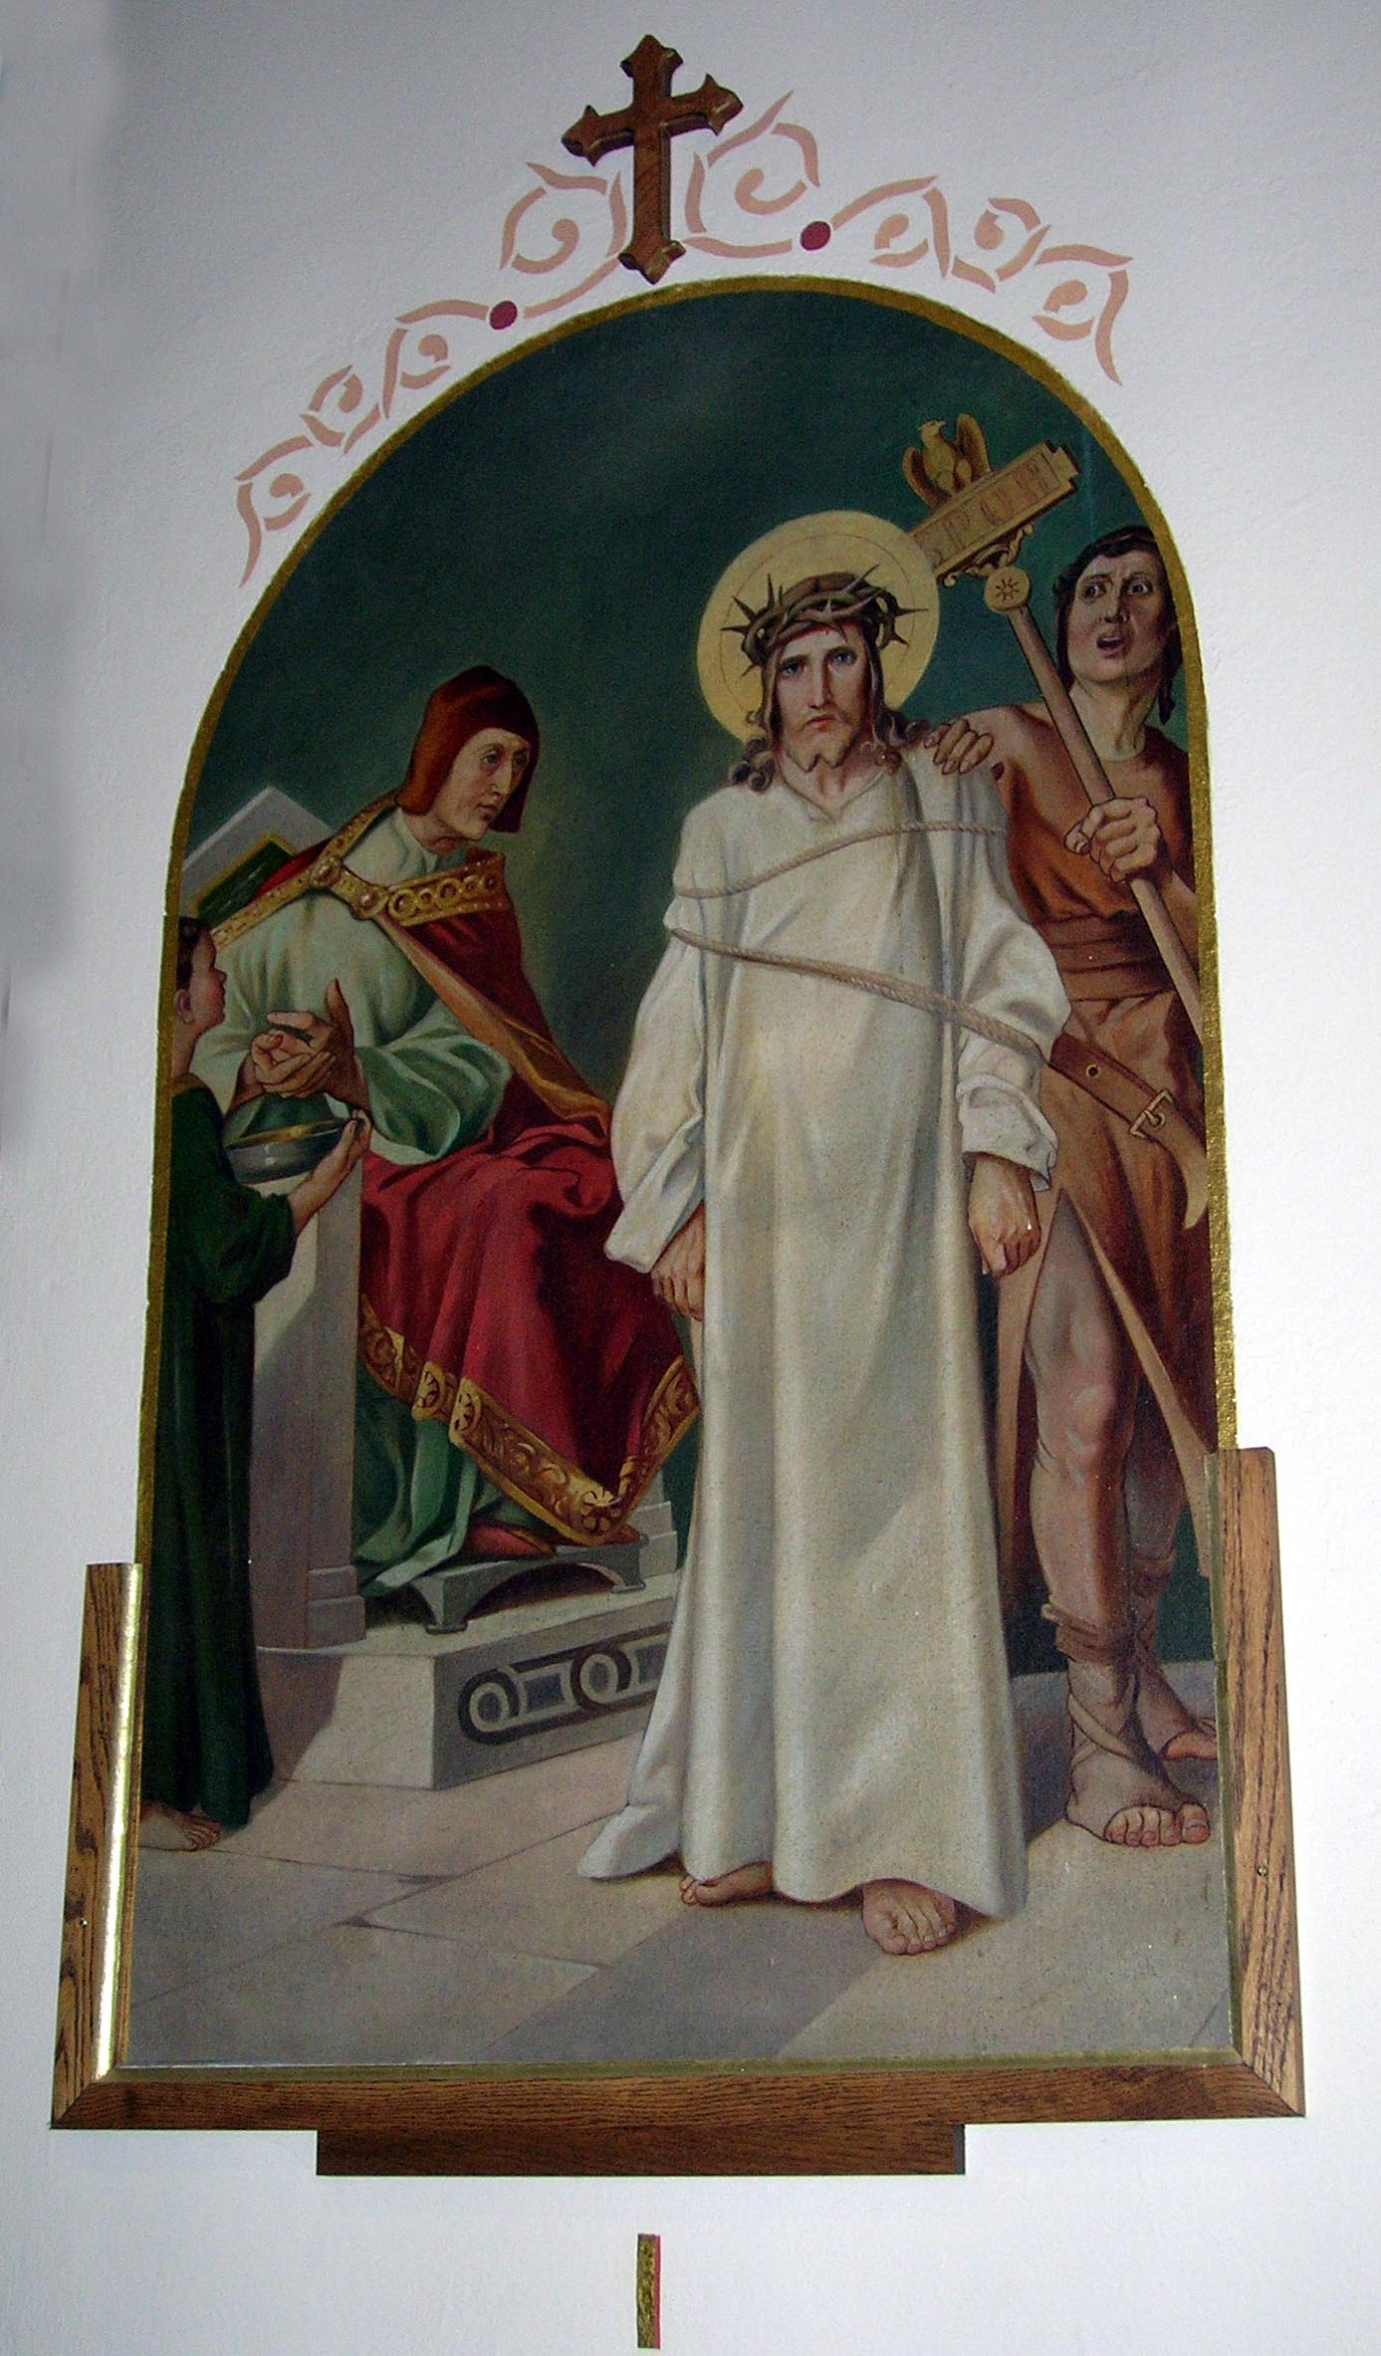Station 1 – Jesus is condemned to death
Consider how Jesus, after having been scourged and crowned with thorns, was unjustly condemned by Pilate to die on the Cross. Pilate tried to remain uninvolved by washing his hands.

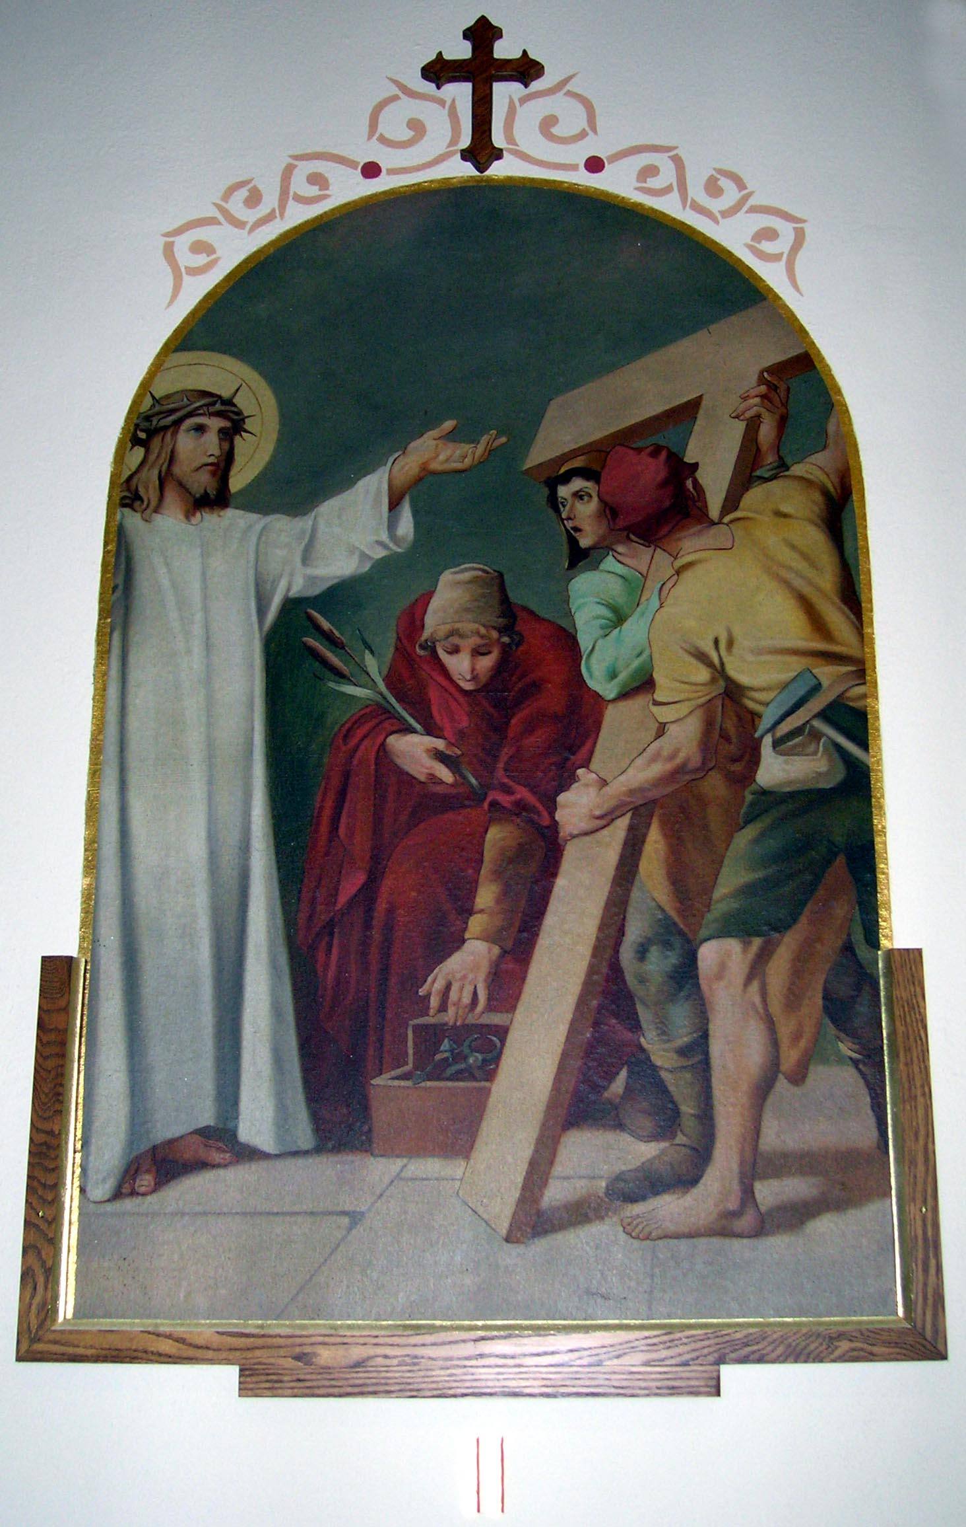Station 2 – Jesus receives His Cross
Consider how Jesus, in making this journey with the Cross on His shoulders, thought of us, and offered for us to His Father the death He was about to undergo. “He was wounded for our sins…in his wounds there is healing for us.”
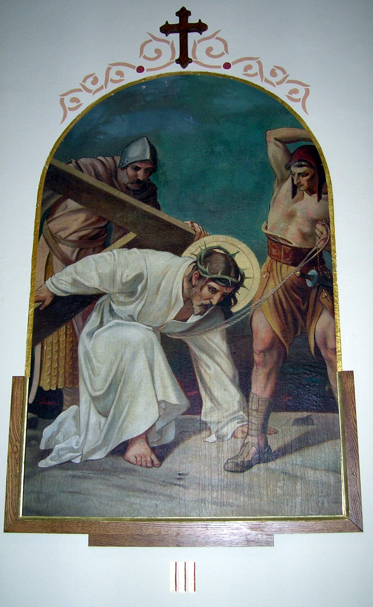Station 3 – Jesus falls the first time under His Cross
Consider this first fall of Jesus under His Cross. His flesh was torn by the scourges, His head was crowned with thorns; He had lost a great quantity of blood. So weakened he could hardly walk. Yet He had to carry this great load upon His shoulders. The soldiers struck him rudely, and He fell several times.

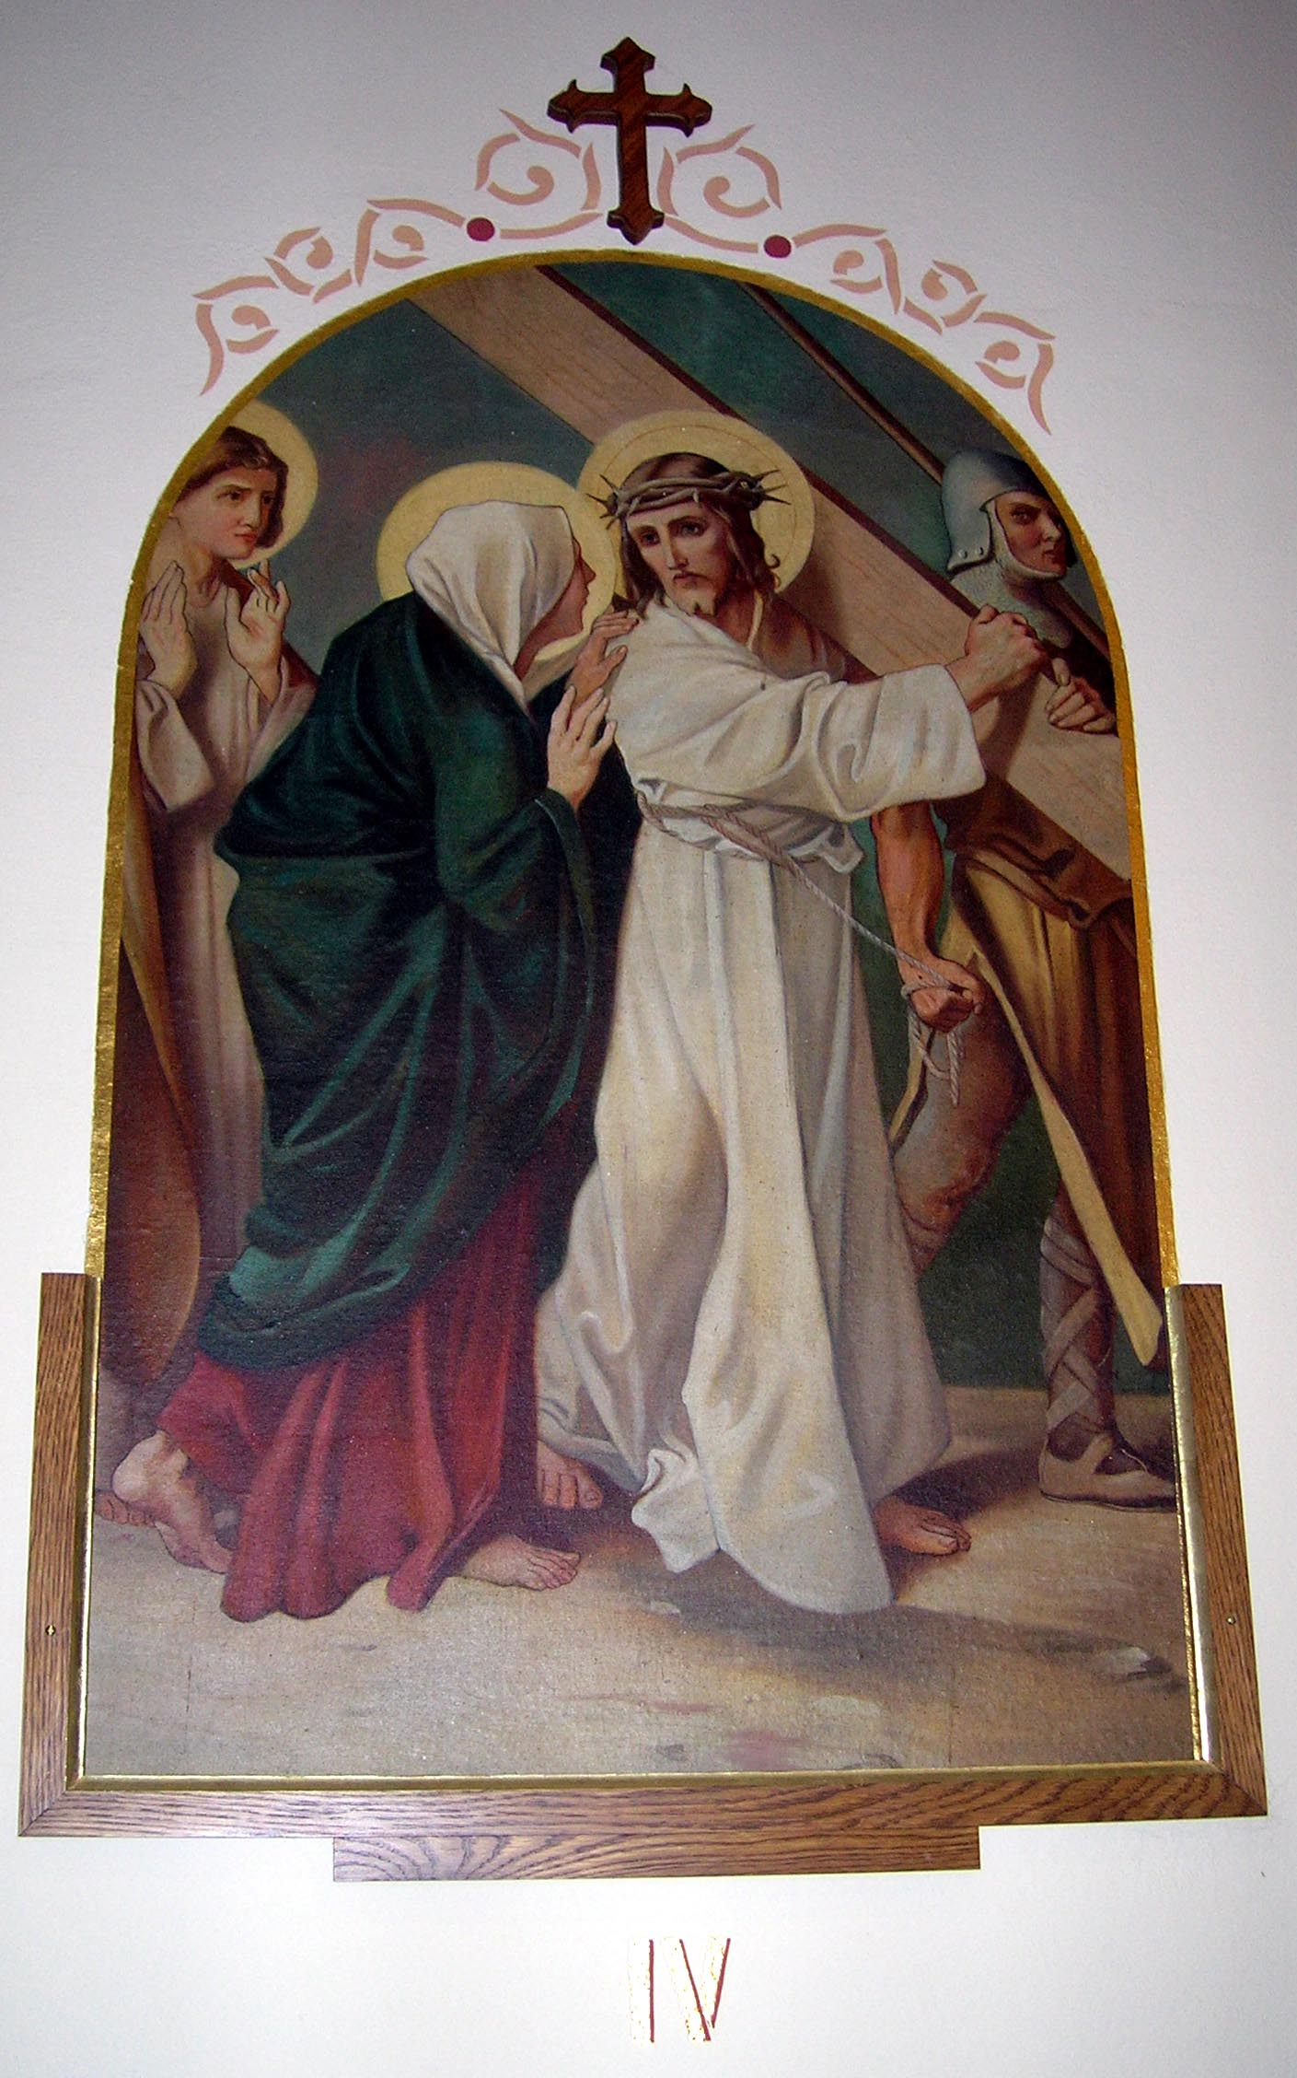Station 4 – Jesus is met by His Mother
Consider the meeting of the Son and the Mother, which took place on this journey. His Cross becomes hers, His humiliation becomes hers. They shared each other’s suffering.

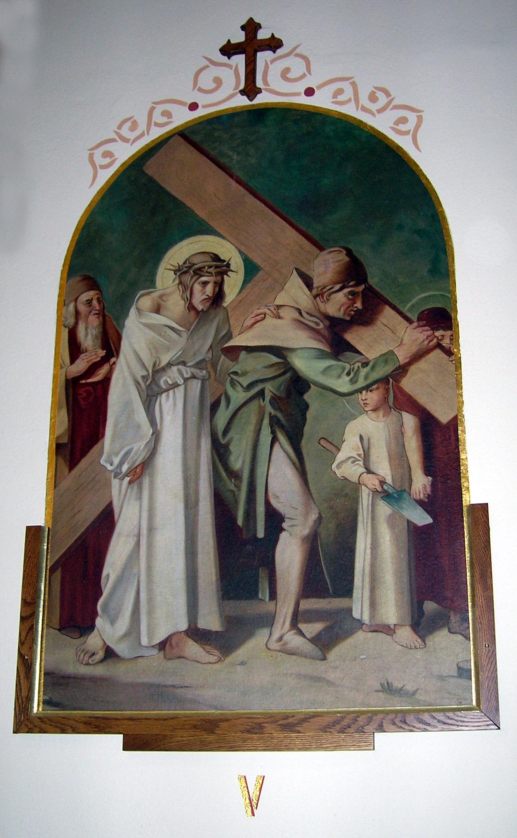Station 5 – Simon of Cyrene helps Jesus to carry His Cross
Consider how the Jews, seeing that at each step Jesus was on the point of expiring, and fearing he would die on the way, whereas they wished Him to die on the Cross, compelled Simon to carry the Cross behind Jesus. How long did he go on resenting being forced to do this?
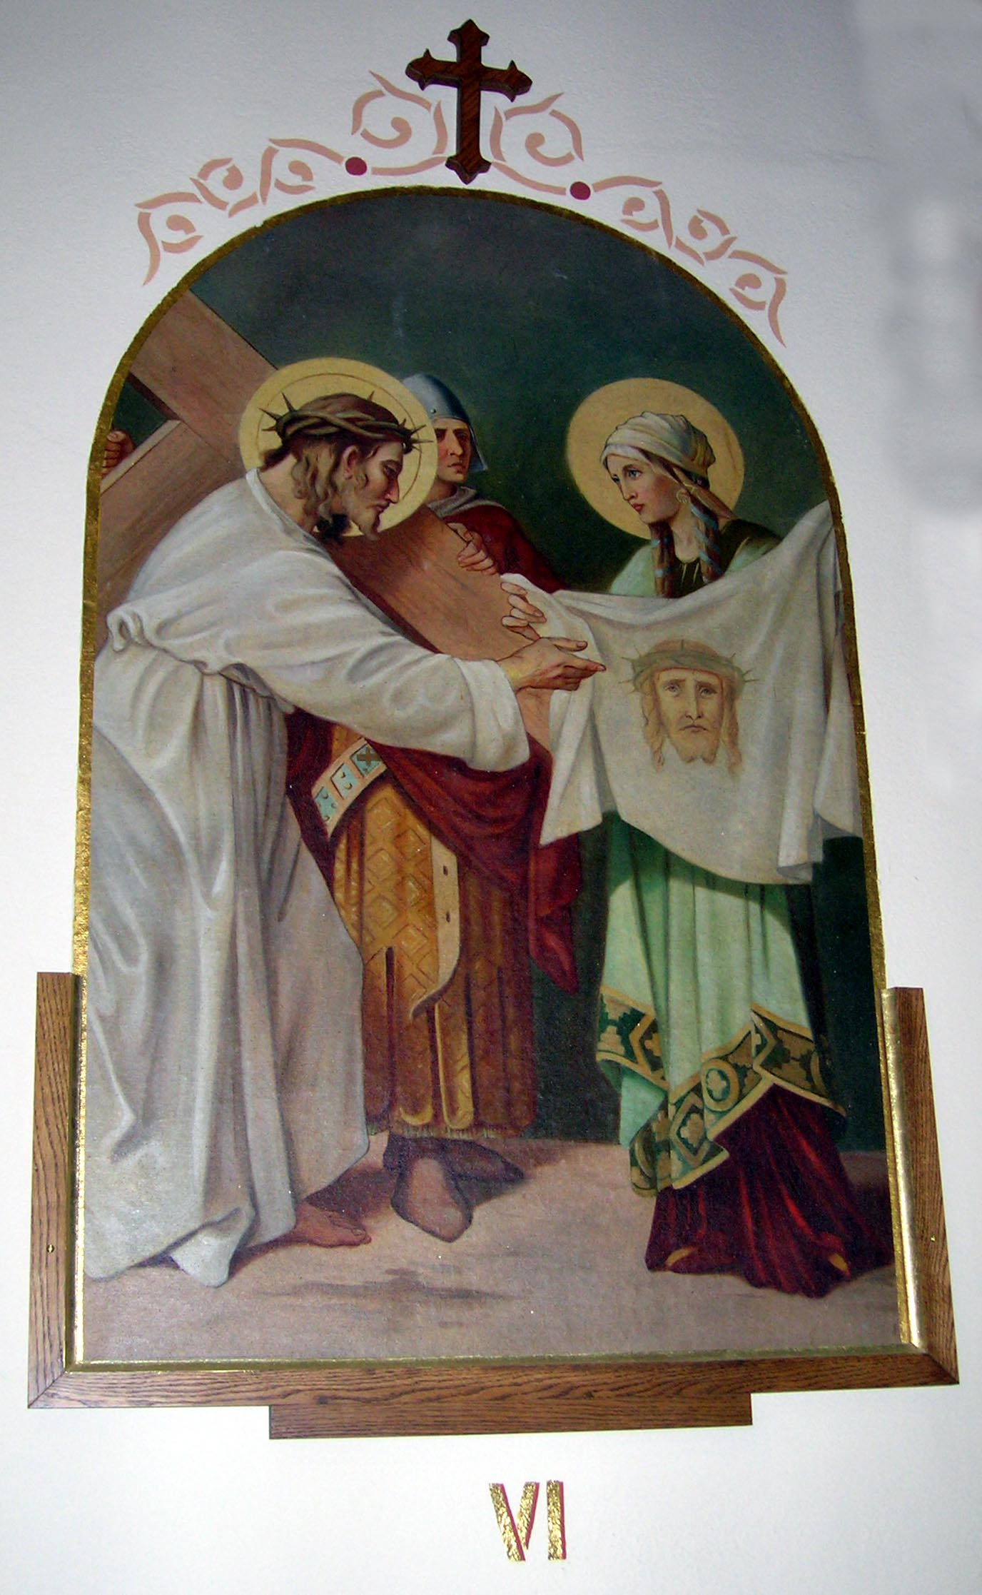 Station 6 – Veronica wipes the face of Jesus
Consider how the holy woman named Veronica, seeing Jesus so ill-used and bathed in sweat and blood, wiped His face with a towel, on which he left the impression of His holy countenance.

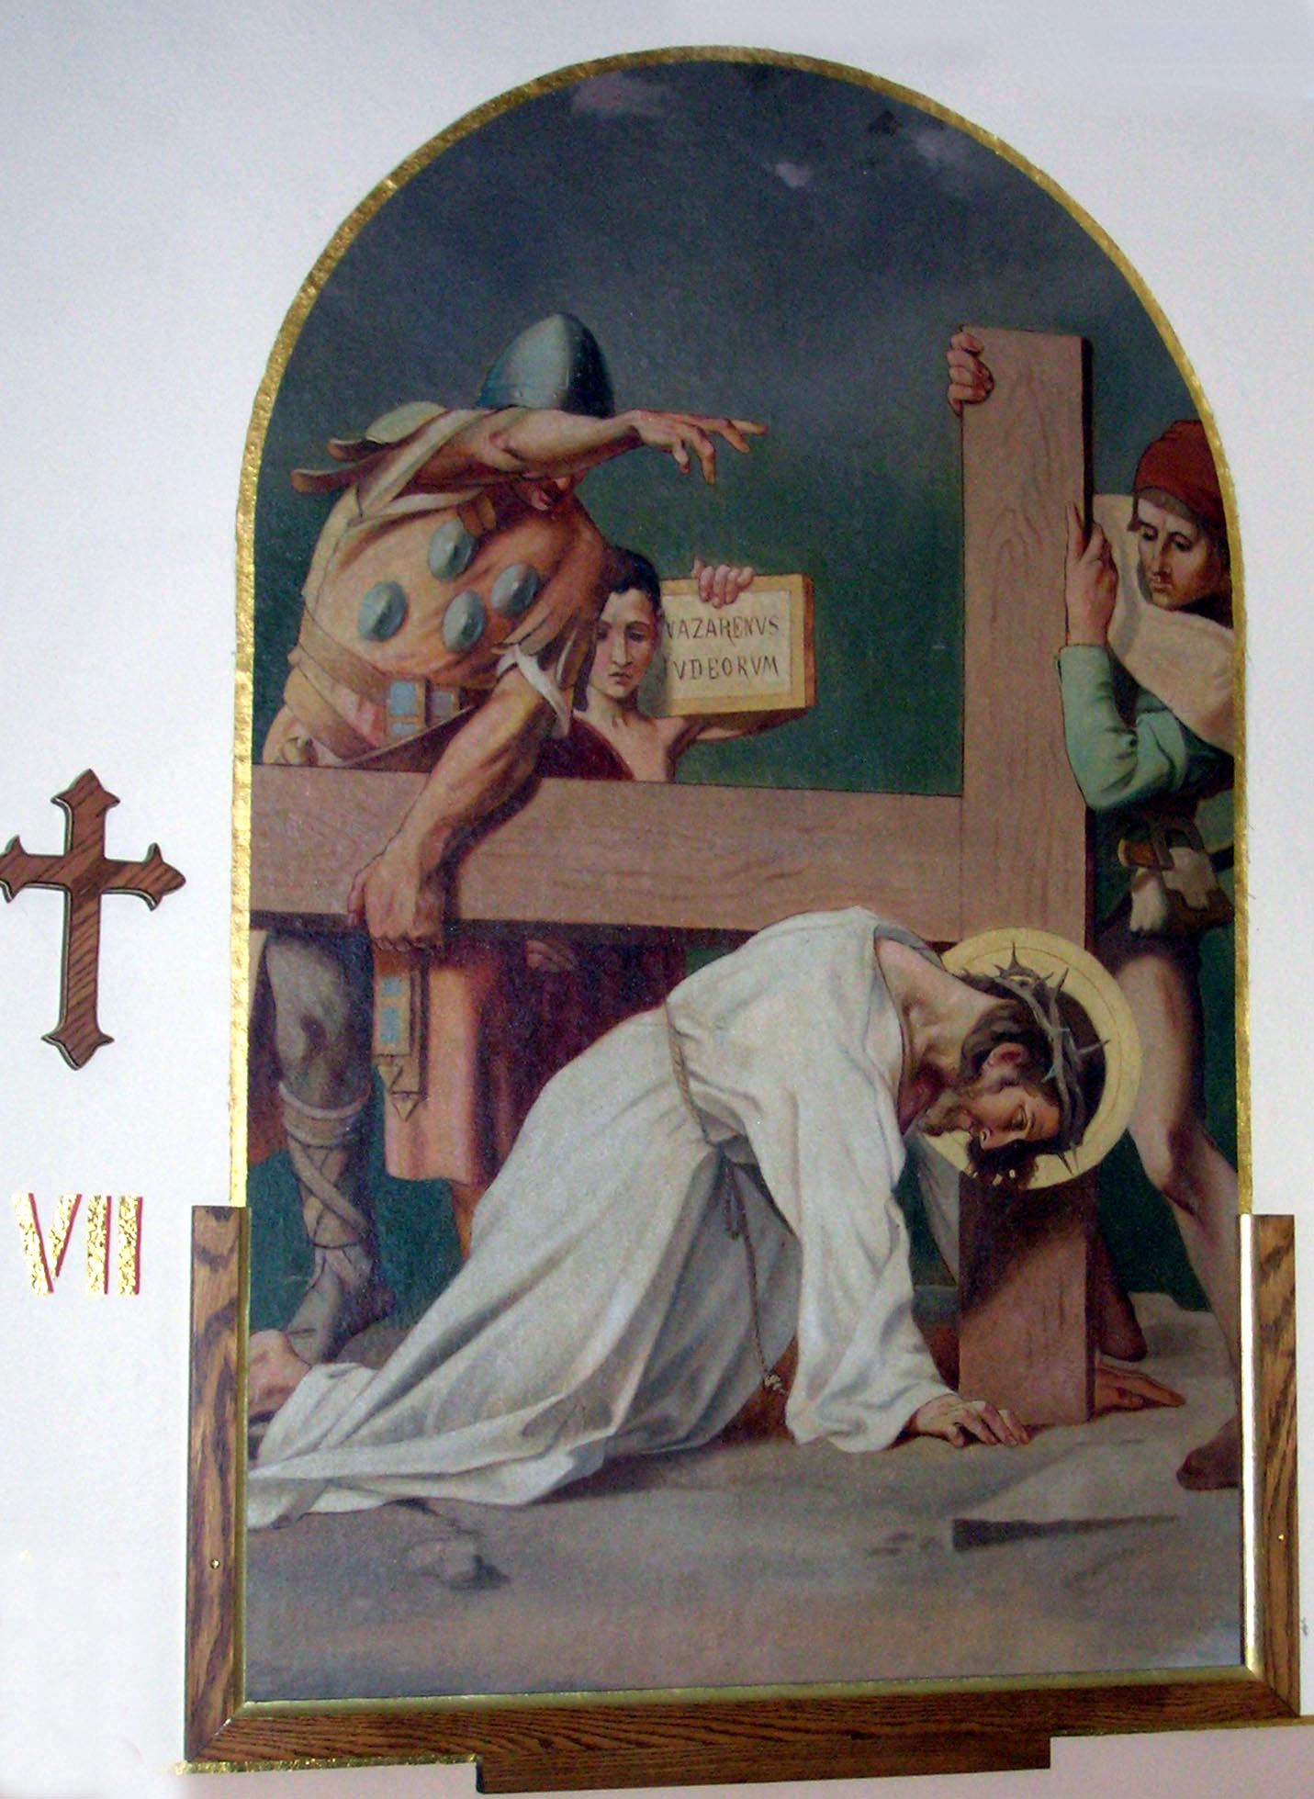Station 7 – Jesus falls the second time
Consider the second fall of Jesus under the Cross; a fall which renews the pain of all the wounds in His head and members. “I am a worm and not a man…the laughingstock of the mob.”

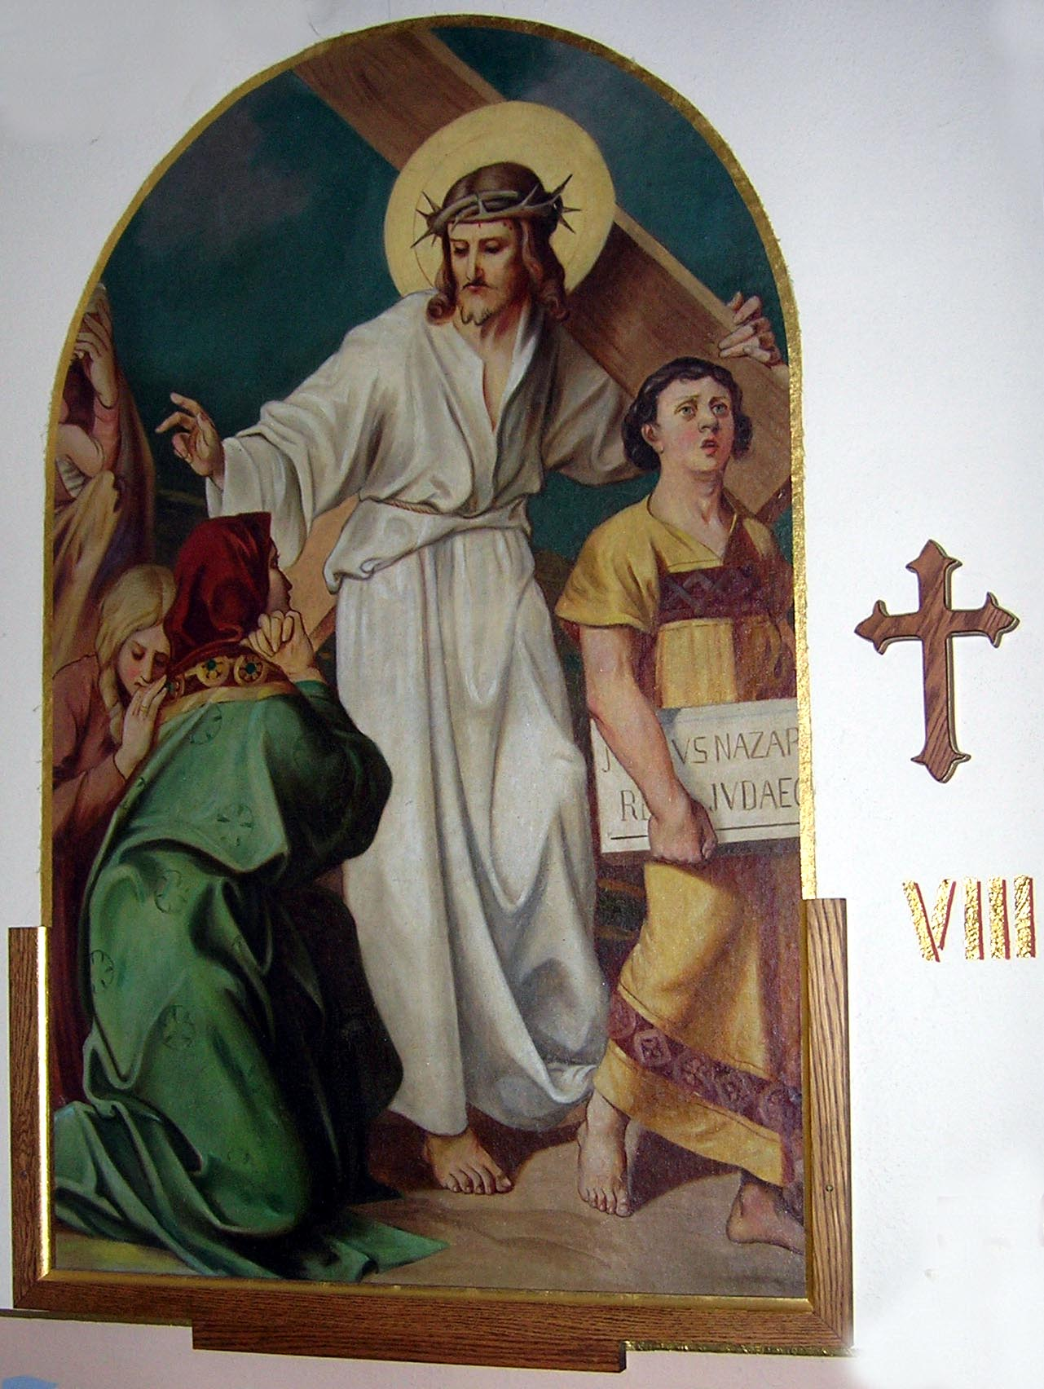Station 8 – Jesus meets the women of Jerusalem
Consider how these women wept with compassion at seeing Jesus in such a pitiable state, streaming with blood as He walked along. “Daughters of Jerusalem,” He said, “weep not for Me, but for yourselves and for your children.” Jesus calls them to repentance.

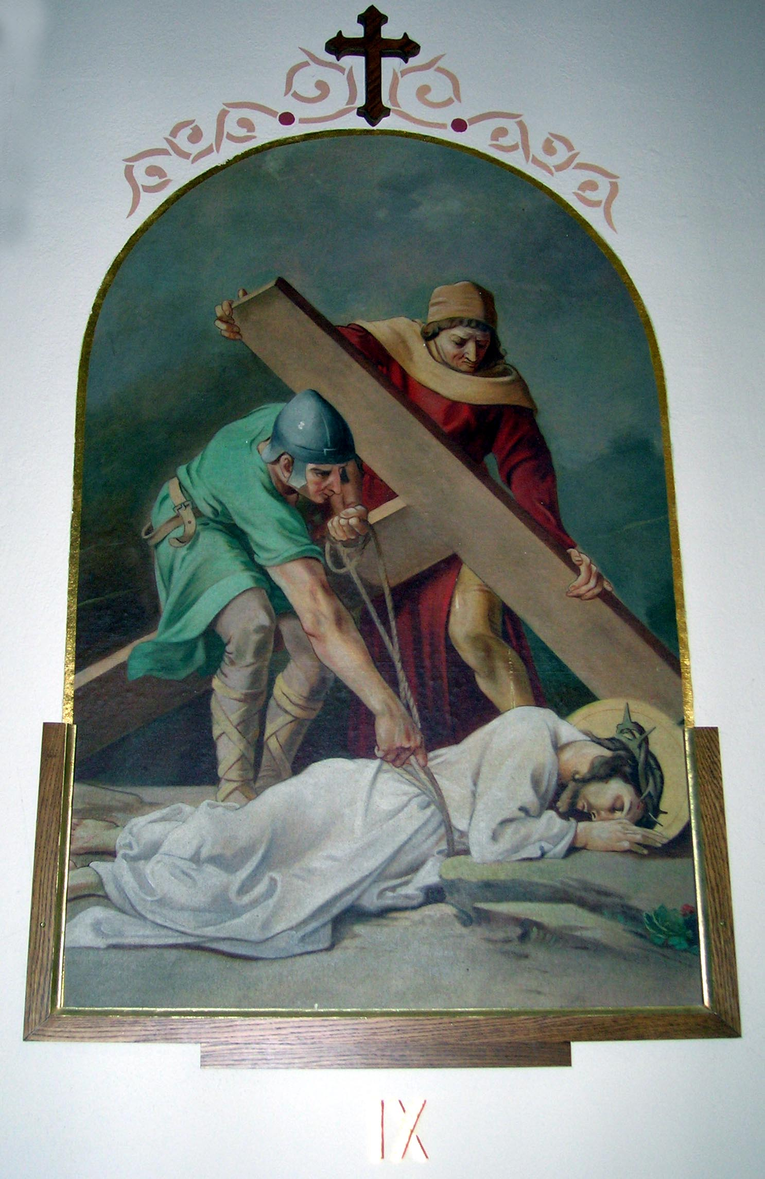Station 9 – Jesus falls for the third time
Consider the third fall of Jesus. His weakness was extreme, and the cruelty of His executioners excessive. They try to hasten His steps when He can hardly move. And who is this who has fallen? Who is Jesus Christ?

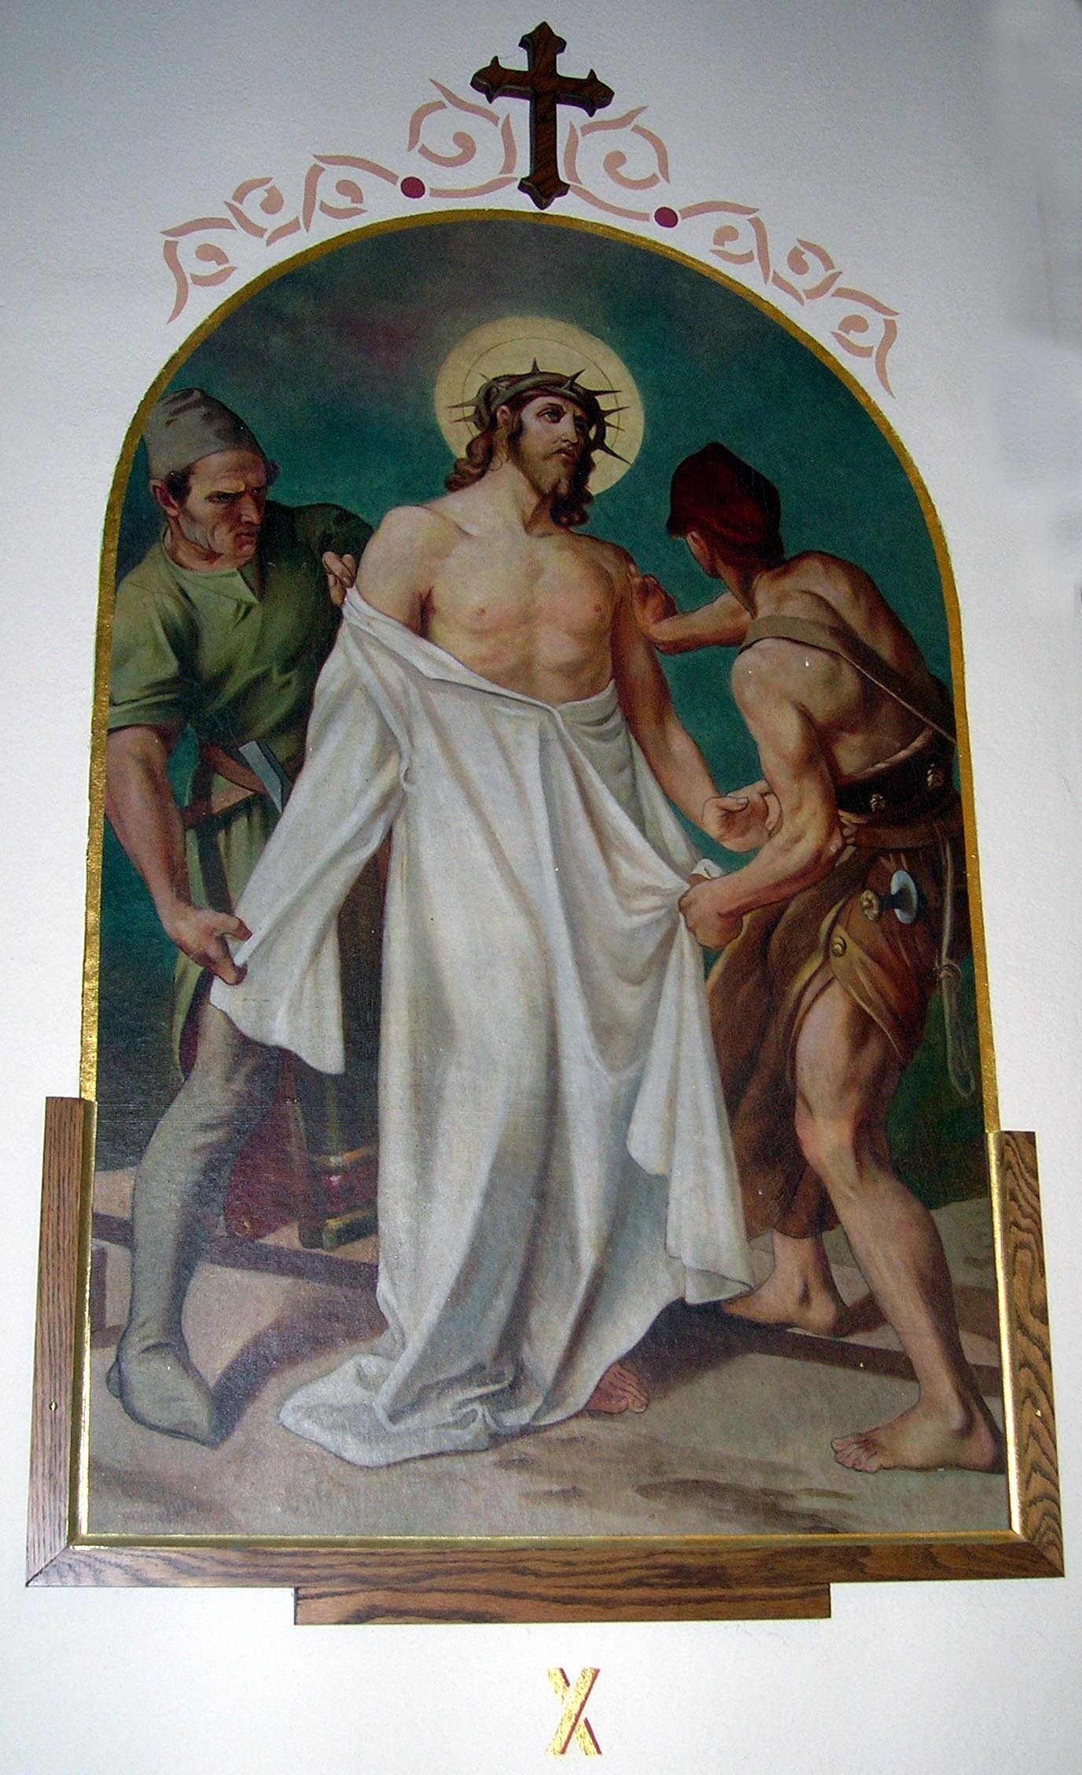Station 10 – Jesus is stripped of His garments
Consider the violence with which Jesus was stripped by His executioners. His inner garments adhered to His torn flesh, and they dragged them off so roughly that the skin came with them. “See I come to do Your will.”

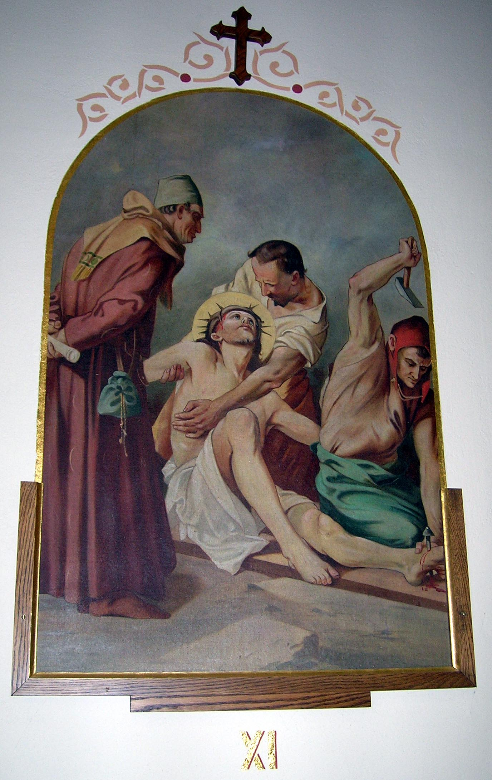Station 11 – Jesus is nailed to the Cross
Consider how Jesus, having been placed on the Cross, extended His hands and offered to His Eternal Father the sacrifice of His life for our salvation. The soldiers fastened Him with nails, and then hoisted Him up. “I, when I am lifted up from the earth, will draw all men to Myself.”

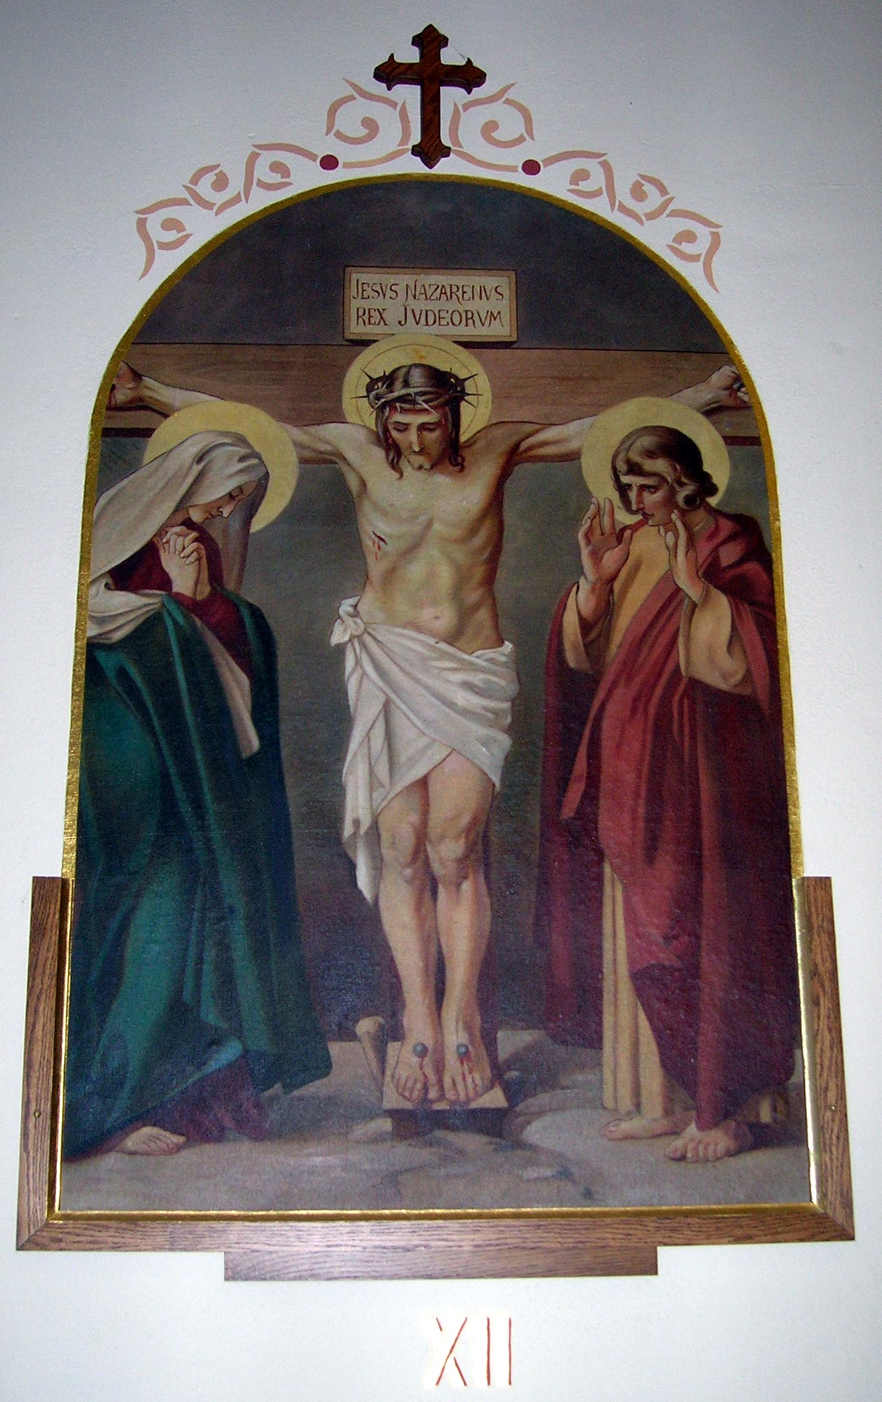Station 12 – Jesus dies on the Cross
Consider how Jesus, being consumed with anguish after three hours of agony on the Cross, abandoned himself to the weight of His body, bowed His head and died. The finest work of the Son in union with the Father. The mystery of the redemption.
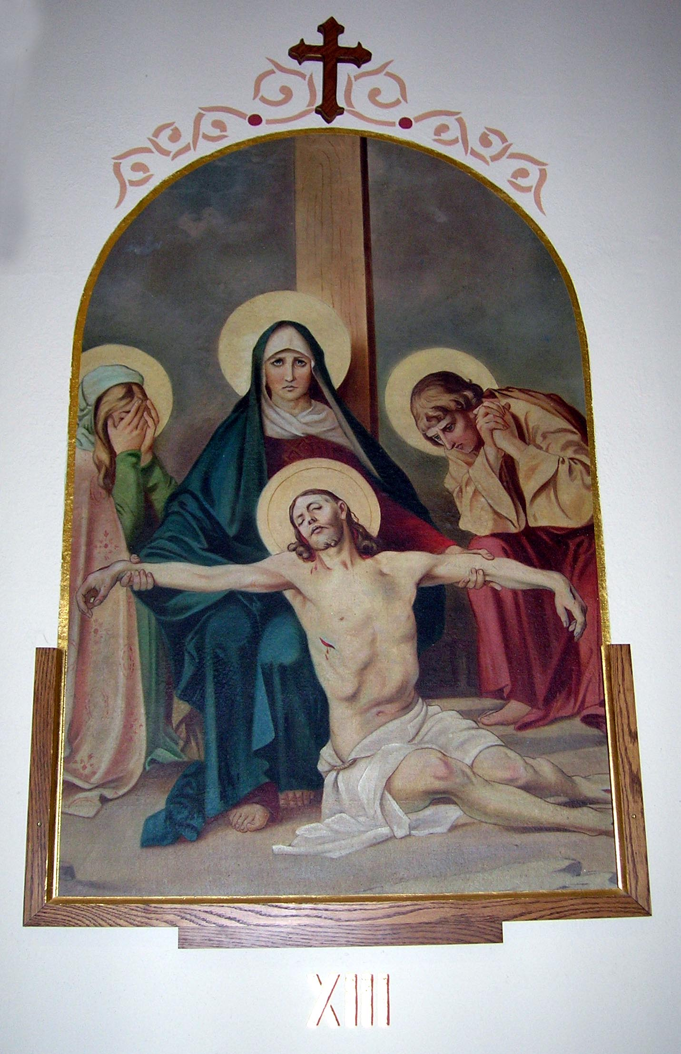Station 13 – Jesus is taken down from the Cross
Consider how, after our Lord had died, two of His disciples, Joseph and Nicodemus, took Him down from the Cross and placed Him in the arms of His afflicted Mother, who received Him with unutterable tenderness, and pressed Him to Her bosom.

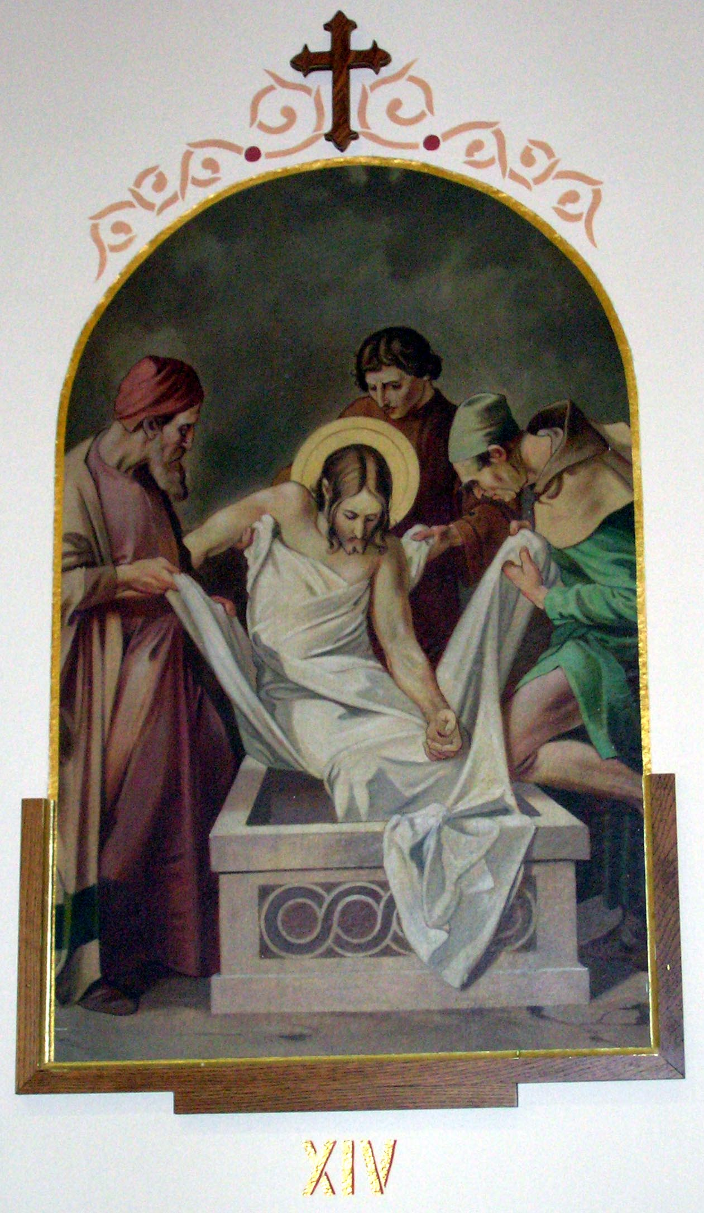Station 14 – Jesus is placed in the tomb
Consider how the disciples, accompanied by His Mother, carried His body to bury it. They closed the tomb, and all came sorrowfully away.

A Quarter of an Hour Before the
Blessed Sacrament
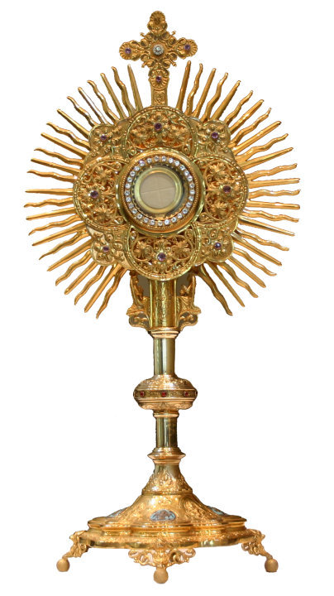
To please Me, dear child, it is not necessary to know much; all that is required is to love Me much, to be deeply sorry for ever having offended Me and desirous of being ever faithful to Me in the future. (Pause)

Speak to Me now as you would to your dearest friends. Tell Me all that now fills your mind and heart. Are there any you wish to commend to Me? Tell Me their names, and tell Me what you would wish Me to do for them. Do not fear, ask for much; I love generous hearts, which, forgetting themselves, wish well to others. (Pause)

Speak to Me of the poor you wish to comfort; tell Me of the sick that you would wish to see relieved. Ask of Me something for those who have been unkind to you, or who have crossed you. Ask much for them all; commend them with all your heart to Me. (Pause)

And ask Me for many graces for yourself. Are there not many graces you would wish to name that would make you happier in yourself; more useful and pleasing to others, more worthy of the love of Me, the dearest Lord, Master, and Spouse of Your soul? Tell Me the whole list of the favors you want of Me. Tell Me them with humility, knowing how poor you are without them, how unable to gain them by yourself; ask for them with much love, that they may make you more pleasing to Me. With all a child’s simplicity, tell me how self-seeking you are, how proud, vain, irritable, how cowardly in sacrifice, how lazy in work, uncertain in your good resolutions; and then ask Me to bless and crown your efforts. Poor child, fear not, blush not at the sight of so many failings; there are Saints in heaven who had the faults you have; they came to Me lovingly, they prayed earnestly to Me, and My grace has made them good and holy in My sight. (Pause)

You should be Mine, body and soul; fear not, therefore, to ask Me gifts of body and mind, health, judgment memory, and success—ask for them for My sake; that God may be glorified in all things. I can grant everything, and never refuse to give what may make a soul dearer to Me and better able to fulfill the will of God. (Pause)

Have you no plans for the future which occupy, perhaps distress, your mind? Tell Me your hopes, your fears. Is it about your future state? Your position among My creatures? Some good you wish to bring to others? In what shall I help and bless your will? (Pause)
And for Me you must have—have you not?—some zeal, some wish to do good to the souls of others. Some, perhaps, who love and care for you, have ceased, almost, to know or care for Me. Shall I give you strength, wisdom and tact, to bring these poor ones close to My heart again? Have you failed in the past? Tell Me how you acted; I will show you why you did not gain all you expected; rely on Me, I will help you, and will guide you to lead others to Me. (Pause)

And what crosses have you, My dear child? Have they been many and heavy ones? Has some one caused you pain? Some one wounded your self-love? Slighted you? Injured you? Lay your head upon My breast, and tell Me how you suffered. Have you felt that some have been ungrateful to you, and unfeeling towards you? Tell Me all, and in the warmth of My heart you will find strength to forgive and even to forget that they have ever wished to pain you. (Pause)

And what fears have you, My child? My providence shall comfort you, My love sustain you. I am never away from you, never can abandon you. Are some growing cold in the interest and love they had for you? Pray to Me for them; I will restore them to you if it be better for you and your sanctification. (Pause)

Have you not some happiness to make known to Me? What has happened since you came to Me last, to console you, to gladden and give you joy. What was it? A mark of true friendship you received? A success unexpected and almost unhoped for? A fear suddenly taken away from you? And did you remember the while, that in all it was My will, My love, that brought all that your heart has been so glad to have? It was My hand, My dear child, that guided and prepared all for you. Look to Me now, My child, and say: “Dear Jesus, I thank You.” (Pause)

You will soon leave Me now; what promises can you make Me? Let them be sincere ones, humble ones, full of love and desire to please Me. Tell Me how carefully you will avoid every occasion of sin, drive from you all that leads to harm, and shun the world—the great deceiver of souls. (Pause)

Promise to be kind to the poor; loving, for My sake, to friends; forgiving to your enemies, and charitable to all, not in word alone and actions, but in your very thoughts. When you have little love for your neighbor, whom you see, you are forgetting Me who am hidden from you. (Pause)

Love all My Saints; seek the help of your holy patrons. I love to glorify them by giving you much through them. Love, above all, My own sweet glorious Mother—she is your mother; love her, speak to her often and she will bring you to Me, and for her sake, I will love and bless You more each day. (Pause)
Return soon to Me again, but come with your heart empty of the world, for I have many more favors to give, more than you can know of; bring your heart so that I may fill it with many gifts of My love. (Pause)

My peace be with you.

Seven Penitential Psalms
Psalm 6: Prayer in Ordeal
Yahweh, do not punish me in Your rage, or reprove me in the heat of anger. Pity me, Yahweh, I have no strength left, heal me, my bones are in torment, my soul is in utter torment. Yahweh, how long will You be?

Come back, Yahweh rescue my soul, save me, if You love me; for in death there is no remembrance of You:
who can sing Your praises in Sheol?

I am worn out with groaning,
every night I drench my pillow
and soak my bed with tears;
my eye is wasted with grief,
I have grown old with enemies all around me.

Away from me, all You evil men!
for Yahweh has heard the sound of my weeping;
Yahweh has heard my petition,
Yahweh will accept my prayer.
Let all my enemies, discredited, in utter torment,
fall back in sudden confusion.

Psalm 32: Candid Admission of Sin
Happy the man whose fault is forgiven,
whose sin is blotted out;
happy the man whom Yahweh
accused of no guilt,
whose spirit is incapable of deceit!

All the time I kept silent, my bones were wasting away
with groans, day in, and day out;
day and night Your hand
lay heavy on me;
my heart grew parched as stubble
in summer drought.

At least I admitted to You I had sinned;
no longer concealing my guilt,
I said, “I will go to Yahweh
and confess my faults.”
And You, You have forgiven the wrong I did,
have pardoned my sin.

That is why each of Your servants prays to You
in time of trouble;
even if floods come rushing down,
they will never reach him.
You are a hiding place for me,
You guard me when in trouble,
You surround me with songs of deliverance.

I will instruct you, and teach you the way to go;
I will watch over you and be your adviser.
Do not be like senseless horse or mule
that need bit and bridle to curb their spirit (to let you get near them).
Many torments await the wicked,
but grace enfolds the man who trusts in Yahweh.

Rejoice in Yahweh,
exult, you virtuous,
shout for joy, all upright hearts.

Psalm 38: Prayer in Distress
Yahweh, do not punish me in Your rage,
or reprove me in the heat of anger.
Your arrows have pierced deep,
Your hand has pressed down on me;
no soundness in my flesh now You are angry,
no health in my bones, because of my sin.

My guilt is overwhelming me,
it is too heavy a burden;
my wounds stink and are festering,
the result of my folly;
bowed down, bent double, overcome.
I go mourning all the day.

My loins are burnt up with fever,
there is no soundness in my flesh:
numbered and crushed and overcome,
my heart groans, I moan aloud.

Lord, all that I long for is known to You,
my sighing is no secret from You;
my heart is throbbing, my strength deserting me,
the light of my eyes itself left me.

My friends and my companions shrink from my wounds,
even the dearest of them keep their distance;
men intent on killing me lay snares,
others, hoping to hurt me, threaten my ruin,
hatching treacherous plots all day.

But I am like the deaf, I do not hear,
like the drunk man who does not open his mouth;
I am like the man who, hearing nothing,
gives no sharp answer in return.

Psalm 51: Miserere
Have mercy on me, O God. In Your goodness,
in Your great tenderness wipe away my faults;
wash me clean of my guilt,
purify me from my sin.

For I am well aware of my faults,
I have my sin constantly in mind,
having sinned against none other then You,
having done what You regard as wrong.

You are just when You pass sentence on me,
blameless when You give judgment.
You know I was born guilty,
a sinner from the moment of conception.

Yet, since You love sincerity of heart,
teach me the secrets of wisdom.
Purify me with hyssop until I am clean;
wash me until I am whiter than snow.

Instill some joy and gladness into me,
let the bones You have crushed rejoice again.
Hide Your face from my sins,
wipe out all of my guilt.

God, create a clean heart in me,
put into me a new and constant spirit,
do not banish me from Your presence,
do not deprive me of Your Holy Spirit.

Be my savior again, renew my joy,
keep my spirit steady and willing;
and I shall teach transgressors the way to You,
and to You the sinners will return.

Save me from death, God my savior,
and my tongue will acclaim Your righteousness;
Lord, open my lips,
and my mouth will speak out Your praise.

Sacrifice gives You no pleasure,
were I to offer holocaust, You would not have it.
My sacrifice is this broken spirit,
You will not scorn this crushed and broken heart.

Show Your favor graciously to Zion,
rebuild the walls of Jerusalem.
Then there will be proper sacrifice to please You
- holocaust and whole oblation –
and young bulls to be offered on Your altar.

Psalm 102: Prayer in Misfortune
Yahweh, hear my prayer,
let my cry for help reach You;
do not hide Your face from me
when I am in trouble;
bend down to listen to me,
when I call, be quick to answer me!
For my days are vanishing like smoke,
my bones smoldering like logs,
my heart shriveling like scorched grass
and my appetite has gone;
whenever I heave a sigh,
my bones stick through my skin.
I live in a desert like the pelican,
in a ruin like the screech owl,
I stay awake, lamenting
like a lone bird on the roof;
my enemies insult me all day long,
those who used to praise me now use me as a curse.

Ashes are the bread I eat,
what I drink I lace with tears,
under Your furious anger,
since You picked me up only to throw me down;
my days dwindle away like a shadow,
I am as dry as hay.

Whereas, Yahweh, You remain for ever;
each generation in turn remembers You!
Rise, take pity on Zion! – the time has come to have mercy on her, the hour has come;
for Your servants prize her stones
and are moved to pity by her dust.

Then will the nations fear the name of Yahweh
and all kings on earth respect Your glory;
when Yahweh builds Zion anew,
He will be seen in his glory;
He will answer the prayer of the abandoned,
He will not scorn their petitions.

Put this on record for the next generation,
so that a race still to be born can praise God:
Yahweh has leaned down from the heights of His sanctuary,
has looked down at earth from heaven,
to hear the sighing of the captive,
and to set free those doomed to die.

Your servants’ sons will have a permanent home,
and their descendants be in Your presence always,
to proclaim the name of Yahweh in Zion,
His praise in Jerusalem;
nations and kingdoms will be united
and offer worship to Yahweh together.

Psalm 130: From the Depths
From the depths I call to You, Yahweh,
Lord, listen to my cry for help!
Listen compassionately
to my pleading!

If You never overlooked our sins, Yahweh,
Lord, could anyone survive?
But You do forgive us;
and for that we revere You.

I wait for Yahweh, my soul waits for Him,
I rely on His promise,
my soul relies on the Lord
More that a watchman on the coming of dawn.
Let Israel rely on Yahweh
as much as the watchman on the dawn!
For it is with Yahweh that mercy is to be found,
and a generous redemption;
it is He who redeems Israel
from all their sins.

Psalm 143: A Humble Entreaty
Yahweh, hear my prayer,
listen to my pleading,
answer me faithfully, righteously;
do not put Your servant on trial,
no one is virtuous by Your standards.

An enemy who hounds me to crush me into the dust,
forces me to dwell in darkness
like the dead of long ago;
my spirit fails me
and my heart is full of fear.
I recall the days of old,
I reflect on all that You did,
I ponder Your deeds;
I stretch out my hands,
like thirsty ground I yearn for You.

Quick, Yahweh, answer me
before my spirit fails;
if You hide Your face much longer,
I shall go down to the Pit like the rest.

Let dawn bring proof of Your love,
for one who relies on You;
let it show the right road,
to one who lifts up his soul to You.

Yahweh, rescue me from my enemies,
I have fled to You for shelter;
teach me to obey You,
since You are my God;
may Your good spirit guide me
on to level ground.

Yahweh, for the sake of Your name,
keep Your promise to save me;
protect me from oppression,
love me, kill my enemies,
destroy my oppressors,
for I am Your servant.

Anima Christi
Soul of Christ, sanctify me.
Body of Christ, save me.
Blood of Christ, inebriate me.
Water from Christ’s side, wash me.
Passion of Christ, strengthen me.
O good Jesus, hear me.
Within Thy wounds hide me.
Suffer me not to be separated from Thee.
From the malicious enemy defend me.
In the hour of my death call me.
And bid me come unto Thee,
That I may praise Thee with Thy saints
and with Thy angels
Forever and ever. Amen.
Christ Be With Me
(St. Patrick’s Breastplate)
Christ be with me, Christ be before me, Christ be behind me, Christ be within me, Christ be beneath me, Christ be above me, Christ be at my right, Christ be at my left, Christ be in the fort, Christ be in the chariot, Christ be in the ship, Christ be in the heart of everyone who thinks of me, Christ be in the mouth of everyone who thinks of me, Christ be in the mouth of everyone who speaks to me, Christ be in every eye that sees me, Christ be in every ear that hears me. Amen.

Jesus, King
(St. Peter Julian Eymard)
Jesus, King of Heaven and earth, I wish you to reign in me, to reign over me; to reign in my soul, to reign in my heart, to reign over my whole life, to reign over my love. Yes, Lord Jesus, come and reign. Let my body be your temple, let my heart be your throne, let my will be your devoted servant; let me be Yours forever, living only of You and for You! Amen.

Oh Joy
Oh joy of men and angels, what could disturb me now that you are present within me? O purity of virgins, sanctify and purify my body and soul. Lamb of God, who takes away the sins of the world, grant me pardon in your mercy. What more could you give me that your very body? You have allowed me to receive the eternal Word, the Author of life, the Son of God, the splendor of the Father’s glory, the creator of angels. Let me do nothing more that just behold you, Lord Jesus, remain in me forever. Amen.

Ten Commandments

- I am the Lord your God: you shall not have strange Gods
before me.
- You shall not take the name of the Lord your God in vain.
- Remember to keep holy the Lord’s Day.
- Honor your father and your mother.
- You shall not kill.
- You shall not commit adultery.
- You shall not steal.
- You shall not bear false witness against your neighbor.
- You shall not covet your neighbor’s wife.
- You shall not covet your neighbor’s goods.

The Sacrament of Reconciliation (Penance)

How to Go to Confession:
The priest greets You,
The penitent says: “Forgive me, Father, for I have
sinned.” You then say how long it has been since Your last Confession,
The penitent tells the priest his/her sins and answers any questions:
The priest will give You some advice and will assign You a penance.
The penitent will next pray the Act of Contrition.
The priest then gives absolution.
The priest will then bid You go in the peace of the Lord.
The penitent says: “Thank You, Father.”

Act of Contrition:
O my God, I am heartily sorry for having offended Thee, and I detest all my sins because I dread the loss of heaven and the pains of hell. But most of all, because they offend Thee, my God, Who art all good and deserving of all my love. I firmly resolve, with the help of Thy grace, to confess my sins, to do penance, and to amend my life. Amen.

Preparation for Confession
Most merciful God, You are our Father in heaven, the fountain of holiness and mercy for all Your creatures. I come to You with confidence to confess my sins and ask Your forgiveness. You do not turn away a humble and contrite heart; nor do You wish the sinner to die but to return to You and live. Bless me and restore me to Your friendship. I acknowledge my ungratefulness towards You and I am deeply sorry for the wrong I have done. I sincerely want to become a better person according to Your holy will, and to imitate Christ Your Son more closely in my life.

O Jesus, my savior, You are the Good Shepherd who seeks out the lost ones of Your flock. I have not followed You. I have left the path You were leading me on, and have preferred my own ways which have harmed me and others. Accept me back into Your flock. I now admit my sins, as sincerely as I would if I were at the moment of my death. Lord Jesus, give me the grace to examine my conscience well.

Holy Spirit come. Enlighten my mind and strengthen my will so that I can recognize my sins for what they are, confess them humbly, and change my ways. Mary my Mother, help me with Your prayers. Holy Angels and saints of God, pray for me. Amen.
Reading: Luke 15:1-7
The tax collectors and sinners were all gathering around to hear him, at which the Pharisees and the scribes murmured, “This man welcomes sinners and eats with them.” Then He addressed this parable to them: “Which among you, if he has a hundred sheep and loses one of them, does not leave the other ninety-nine in the wilderness, and go after the one which is lost, until he finds it? And when he has found it, he lays it on his shoulders, rejoicing. And when he comes home, he calls together his friends and his neighbors, saying to them, “Rejoice with me, for I have found my sheep which was lost.”

Examination of Conscience
This suggested form for an examination of conscience should be completed and adapted to meet the needs of different individuals and to follow local usages.

In an examination of conscience, before the sacrament of penance, each individual should ask himself/herself these questions in particular:

- What is my attitude to the sacrament of Penance? Do I sincerely want to be set free from sin, to turn again to God, to begin a new life, and to enter into a deeper friendship with God? Or do I look on it as a burden, to be undertaken as seldom as possible?

- Did I forget to mention, or deliberately conceal, any grave
sins in past confessions?

- Did I perform the penance I was given? Did I make reparation for any injury to others? Have I tried to put into practice my resolution to lead a better life in Keeping with the Gospel?

Each individual should examine his/her life in the light of God’s word.

I. The Lord says: “You shall love the Lord Your God with
Your whole heart.”

1. Is my heart set on God, so that I really love Him above all things and am faithful to His commandants, as a son loves his father? Or am I more concerned about the things of this world? Have I a right intention in what I do?

2. God spoke to us in His Son. Is my faith in God firm and secure? Am I wholehearted in accepting the Church’s teaching? Have I been careful to grow in my understanding of the faith, to hear God’s word, to listen to instructions on the faith, to avoid dangers to faith? Have I been always strong and fearless in professing my faith in God and the Church? Have I been willing to be known as a Christian in private and public life?

3. Have I prayed morning and evening? When I pray, do I really raise my mind and heart to God or is it a matter of words only? Do I offer God my difficulties, my joys, and my sorrows? Do I turn to God in time of temptation?

4. Have I love and reverence for God’s name? Have I
offended him in blasphemy, swearing falsely, or taking his name in vain? Have I shown disrespect for the Blessed Virgin Mary and the saints?

5. Do I keep Sundays and feast days holy by taking a full part, with attention and devotion, in the liturgy, and especially in the Mass? Have I fulfilled the precept of annual confession and of communion during the Easter Season?

6. Are there false gods that I worship by giving them greater attention and deeper trust than I give to God: money, superstition, spiritism, or other occult practices?

II. The Lord says: “Love one another as I have loved You.”
1. Have I a genuine love for my neighbors? Or do I use them for my own ends, or do to them what I would not want done to myself? Have I given grave scandal by my words or actions?

2. In my family life, have I contributed to the well-being and happiness of the rest of the family by patience and genuine love? Have I been obedient to parents, showing them proper respect and giving them help in their spiritual and material needs? Have I been careful to give a Christian upbringing to my children, and to help them by good example and by exercising authority as a parent? Have I been faithful to my husband/wife in my heart and in my relations with others?

3. Do I share my possessions with the less fortunate? Do I do my best to help the victims of oppression, misfortune, and poverty? Or do I look down on my neighbor, especially the poor, the sick, the elderly, strangers, and people of other races?
4. Does my life reflect the mission I received in Confirmation? Do I share in the apostolic and charitable works of the Church and in the life of my parish? Have I helped to meet the needs of the Church and of the world and prayed for them: for unity in the Church, for the spread of the Gospel among the nations, for peace and justice, etc.?

5. Am I concerned for the good and prosperity of the human community in which I live, or do I spend my life caring only for myself? Do I share to the best of my ability in the work of promoting justice, morality, harmony, and love in human relations? Have I done my duty as a citizen? Have I paid my taxes?

6. In my work or profession am I just, hard-working, honest, serving society out of love for others? Have I paid a fair wage to my employees? Have I been faithful to my promises and contracts?
7. Have I obeyed legitimate authority and given it due respect?

8. If I am in a position of responsibility or authority, do I use this for my own advantage or for the good of others, in a spirit of service?

9. Have I been truthful and fair, or have I injured others by deceit, calumny (slander), detraction, rash judgment, or violation of a secret?

10. Have I done violence to others by damage to life or limb, reputation, honor, or material possessions? Have I involved them in loss? Have I been responsible for advising an abortion or procuring one? Have I kept up hatred for others? Am I estranged from others through quarrels, enmity, insults, anger? Have I been guilty of refusing to testify to the innocence of another because of selfishness?

11. Have I stolen the property of others? Have I desired it unjustly and inordinately? Have I damaged it? Have I made restitution of other people’s property and made good their loss?

12. If I have been injured, have I been ready to make peace for the love of Christ and to forgive, or do I harbor hatred and the desire for revenge?

III. Christ our Lord says: “Be perfect as Your Father is
perfect.”
1. Where is my life really leading me? Is the hope of eternal life my inspiration? Have I tried to grow in the life of the Spirit through prayer, reading the word of God and meditating on it, receiving the sacraments, self-denial? Have I been anxious to control my vices, my bad inclinations and passions, e.g., envy, love of food and drink? Have I been proud and boastful, thinking myself better in the sight of God and despising others as less important than myself? Have I imposed my own will on others, without respecting their freedom and rights?

2. What use have I made of time, of health and strength, of the gifts God has given me to be used like the talents in the Gospel? Do I use them to become more perfect every day? Or have I been lazy and too much given to leisure?

3. Have I been patient in accepting the sorrows and disappointments of life? How have I performed mortification so as to “fill up what is wanting to the sufferings of Christ”? Have I kept the percept of fasting and abstinence?

4. Have I kept my senses and my whole body pure and chaste as a temple of the Holy Spirit consecrated for resurrection and glory, and as a sign of God’s faithful love for men and women, a sign that is seen most perfectly in the sacrament of matrimony? Have I dishonored my body by fornication, impurity, unworthy conversation or thoughts, evil desires, or actions? Have I given in to sensuality? Have I indulged in reading, conversation, shows, and entertainments that offend against Christian and human decency? Have I encouraged others to sin by my own failure to maintain these standards? Have I used the abortive or contraceptive pill or other artificial methods of avoiding conception?

5. Have I gone against my conscience out of fear or hypocrisy?

6. Have I always tried to act in the true freedom of the sons of God according to the law of the Spirit, or am I the slave of forces within me?

Jesus Prayer – Lord Jesus, Son of God, have mercy on me, a sinner.

Thanksgiving After Confession
Say Your penance and add the Magnificat or Prayer of Thanksgiving.

The Magnificat
My soul proclaims the greatness of the Lord.
My spirit rejoices in God my Savior
for He has looked with favor on His lowly servant.

From this day all generations will call me blessed:
The Almighty has done great things for me,
and holy is His Name.

He has mercy on those who fear Him
in every generation.
He has shown the strength of his arm,
He has scattered the proud in their conceit.

He has cast down the mighty from their thrones,
and has lifted up the lowly.

He has filled the hungry with good things,
and the rich He has sent away empty.

He has come to the help of His servant Israel
for He has remembered His promise of mercy,
the promise He made to our fathers, to Abraham and His children for ever.

Prayer of Thanksgiving:
Almighty and wonderful God, how wonderfully You created man and still more wonderfully remade him. You do not abandon the sinner but seek him out with a father’s love. You sent Your Son into the world to destroy sin and death by His passion, and to restore life and joy by His resurrection. You sent the Holy Spirit into our hearts to make us Your children and heirs to Your kingdom. You constantly renew our spirit in the sacrament of Your redeeming love, freeing us from slavery to sin and transforming us ever more closely into the likeness of Your beloved Son. We thank You for the wonders of Your mercy and with heart and hand and voice we join with the whole Church in a new song of praise: Glory to You through Christ in the Holy Spirit now and forever. Amen.

Novena to St. Joseph
O St. Joseph, whose protection is so great, so strong so prompt before the throne of God, I place in you my desires. O St. Joseph, help me by your powerful intercession, and obtain for me from Jesus spiritual blessings. So that having engaged here below your heavenly power, I may offer thanksgiving and homage to the most loving of Fathers. O St. Joseph, I never grow tired contemplating you, and Jesus asleep in your arms; I dare not approach while He reposes near your heart. Press Him in my name and kiss His dear head for me and ask Him to return the kiss when I draw my dying breath. Amen. St. Joseph, pray for me.

Say for nine mornings for anything You may desire.

Healing Prayers

Sacred Heart of Jesus, You invite all who are heavily burdened to come to You and find rest. Teach me to reach out to You in my need. Help me to lead others to Your Sacred Heart. Touch my soul with Your compassion for others. Touch my heart with Your courage and love for all. Touch my mind with Your wisdom and grace. Touch gently my life with Your healing hand. Amen.

Lord Jesus Christ, You who traveled throughout Galilee healing the sick, enabling the blind to see and the lame to walk, bring healing to Your people who need it this day. Grant relief to the ones who suffer pain and physical torment. Give peace to those whose minds are tortured by mental illness and anxiety. Comfort those who are alone in their suffering; may Your people reach out to them and to all the needy this day. Send Your grace to the caregivers that they might be gentle and effective agents of Your loving mercy. May our suffering be joined with Yours to bring healing throughout the world. Amen.

Additional Daily Prayers


Morning Prayer:
Jesus, Good Shepherd, I place in Your hands this day all my work and play, suffering and joy. Guide me and all I love, keep us safe from harm and bring us safely home to You. Amen.

A Morning Prayer:
Most Sacred Heart of Jesus, You are the source of every grace and blessing, I adore You and I love You. I offer You my prayers, works, joys and sufferings of this day. Help me be humble, patient, pure of heart, and obedient to Your will. Protect me from all danger and harm. Give me health of body and mind. May Your love and peace be always with me. Amen.

Prayer in Time of Need:
O Lord, in my present need, help me believe that You are aware of my anxiety and will do what is best for me. Give me the strength to trust You and to put the present and future in Your merciful hands. Amen.

Evening Prayer:
Lord God, thank You for all that has happened this day. I accept everything from Your loving hands. Keep me and all I love safe throughout the night, for I place my trust in You. Amen.

Evening Prayer:
My God, I adore You and I love You. I thank You for having created me, for having made me Your child, and for watching over me this day. Forgive me for the sins and faults I have committed this day. Please accept the good I may have done. Watch over me while I sleep and deliver me from all harm. May Your presence and grace be always with me. Amen.

Psalm 23 – The Good Shepherd

The Lord is my shepherd; I shall not want.
He makes me to lie down in green pastures;
He leads me beside the still waters.
He restores my soul;
He leads me in the paths of righteousness
For His name’s sake.

Yea, though I walk through the valley of the shadow of death,
I will fear no evil;
For You are with me;
Your rod and Your staff, they comfort me.

You prepare a table before me in the presence of my enemies,
You anoint my head with oil;
My cup runs over.
Surely goodness and mercy shall follow me
All the days of my life;
And I will dwell in the house of the Lord Forever.

Psalm 27
In God’s Company There is no Fear
The Lord is my life and my salvation, whom shall I fear?
The Lord is the fortress of my life, of whom should I be afraid?

When evil men advance against me to devour my flesh,
They, my opponents, my enemies, are the ones who stumble and fall.

Though an army pitched camp against me, my heart would not fear;
Though war were waged against me, my trust would still be firm.

One thing I ask of the Lord, one think I seek:
To dwell in the house of the Lord all the days of my life,
To enjoy the sweetness of the Lord and to consult Him in His Temple.

For He shelters me under His awning in times of trouble;
He hides me deep in His tent, sets me high on a rock.

And now my head is held high over the enemies who surround me,
In His tent I will offer exultant sacrifice.

I will sing, I will play for Yahweh!

Psalm 130
O Lord, From the depths of despair I cry for your help. “Hear me! Answer! Help me!”

Lord, if you keep in mind our sins then who can ever get an answer to his prayers? But you forgive! What an awesome thing this is!

That is why I wait expectantly, trusting God to help, for he has promised.

I long for him more than sentinels long for the dawn.

O Israel, hope in the Lord; for he is loving and kind, and comes to us with armloads of salvation.

He himself shall ransom Israel from her slavery to sin.

Serenity Prayer

Lord God, grant me the serenity to accept the things I cannot change; courage to change the things I can; and the wisdom to know the difference.

Prayer of Thanksgiving
Almighty Father, You are lavish in bestowing all Your gifts, and we give You thanks for the favors You have given to us.

In Your goodness You have favored us and kept us safe in the past. We ask that you continue to protect us and to shelter us in the shadow of Your wings. We ask this through Christ our Lord. Amen.

Prayers for the Sick
Lord Jesus, Who went about doing good and healing all, we ask You to bless Your friends who are sick. Give them the strength in body, courage in spirit, and patience in pain.

Let them recover their health, so that, restored to the Christian community, they may joyfully praise Your name, for You live and reign for ever and ever. Amen.
Dear Jesus, Divine Physician and Healer of the Sick, we turn to You in this time of illness. O dearest Comforter of the troubled, alleviate our worry and sorrow with Your gentle love, and grant us the grace and strength to accept this burden. Dear God, we place our worries in Your hands. We place our sick under Your care and humbly ask that You restore Your servant to health again. Above all, grant us the grace to acknowledge Your holy will and know that whatsoever You do, You do for the love of us. Amen.

Prayer for the Addicted
God of mercy, We bless You in the name of Your Son, Jesus Christ, who ministered to all who came to him. Give Your strength to (name of the person), one of Your children, enfold him/her in Your love and restore him/her to the freedom of God’s children.

Lord, look with compassion on all those who have lost their health and freedom. Restore to them the assurance of Your unfailing mercy, strengthen them in the work of recovery, and help them to resist all temptation. To those who care for them, grant patience and understanding and a love that perseveres. We ask this through Christ our Lord. Amen.

Prayer to St. Alphonsus
(Patron of Arthritis Sufferers)
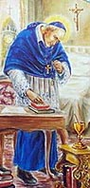
Saint Alphonsus, loving Father of the poor and sick, all your life you devoted yourself with charity towards those who suffer sickness. I invoke you as the patron of those who suffer with arthritis since you were afflicted with this disease in your lifetime. Look with compassion on me in my suffering. Full of confidence in your intercession I come to you for help in my present need…(Mention need). Amen.

In Thanksgiving for a Favor Received
Thank You, O God, for hearing my prayer and granting my request. Thank You for all the kindness You have shown me.

Thank You, Father, for Your great love in giving me my life, for Your great patience in preserving me despite my sinfulness, for Your protection in the past and for the opportunity to serve and honor You in the future.

Thank You, Lord Jesus, for keeping me numberless times from sin and death by the toils of Your life, the sufferings of Your Passion, and by Your victorious Resurrection.

Thank You, Holy Spirit of God, for bestowing so many graces upon my soul and for having so frequently renewed Your life within me.
May my life, from now on, be a sign of my gratefulness. Amen.

Prayer of Spouses for Each Other

Lord Jesus, grant that I and my spouse may have a true and understanding love for each other. Grant that we may both be filled with faith and trust. Give us the grace to live with each other in peace and harmony.

May we always bear with one another’s weaknesses and grow from each other’s strengths. Help us to forgive one another’s failings and grant us patience, kindness, cheerfulness and the spirit of placing the well-being of one another ahead of self.
May the love that brought us together grow and mature with each passing year. Bring us both ever closer to You through our love for each other. Let our love grow to perfection. Amen.

Prayer to End Abortion

Lord God, I thank you today for the gift of my life,
And for the lives of all my brothers and sisters.
I know there is nothing that destroys more life than abortion,
Yet I rejoice that you have conquered death
By the Resurrection of Your Son.
I am ready to do my part in ending abortion.
Today I commit myself
Never to be silent,
Never to be passive,
Never to be forgetful of the unborn.
I commit myself to be active in the pro-life movement,
And never to stop defending life
Until all my brothers and sisters are protected,
And our nation once again becomes
A nation with liberty and justice
Not just for some, but for all.
Through Christ our Lord. Amen!
Prayer for Our Nation

Giver of life,
we entrust the United States of America to
Your loving care.
You are the rock on which this nation was founded.
You alone are the true source of our cherished rights to life,
liberty and the pursuit of happiness.
Reclaim this land for Your glory
and dwell among Your people.
Send Your spirit to touch the hearts of our nation’s leaders.
Open their minds to the great worth of human life
and the responsibilities that accompany human freedom.
Remind Your people that true happiness
is rooted in seeking and doing Your will.
Through the intercession of Mary Immaculate,
Patroness of our land,
grant us the courage to reject
the “culture of death.”
Lead us into a new millennium of life.
We ask this through Christ Our Lord.
Amen.

O Salutaris Hostia
Note: The text of this hymn was composed by St. Thomas Aquinas and along with Tantum Ergo, is strongly associated with Eucharistic Adoration, particularly, the Benediction of the Blessed Sacrament. There are variations on the melody.
O Salutaris Hostia
Quae coeli pandis ostium
Bella premunt hostilia
Da robur fer auxilium

Uni trinoque Domino
Sit sempi terna gloria
Qui vitam sine termino
Nobis donet in patria A-men.

Our Father – Pater Noster
English Latin
Our Father Pater Noster
Who art in heaven, qui es in caelis,
Hallowed be thy name. sanctificetur nomen tuum.
Thy kingdom come, Adveniat regnum tuum.
Thy will be done, Fiat voluntas tua,
On earth, as it is in heaven. sicut in caelo et in terra.
Give us this day our daily bread, Panem nostrum quotidianum da
And forgive us our trespasses, nobis hodie,
As we forgive those et dimitte nobis debita nostra,
Who trespass against us. sicut et nos
And lead us not into temptation, dimittimus debitoribus nostris.
But deliver us from evil. Et ne nos inducas in tentationem:
sed libera nos a malo.

Hail Mary – Ave Maria
English Latin
Hail Mary, full of grace, Ave Maria gratia plena,
The Lord is with thee. Dominus tecum
Blessed art thou among women Benedicta tu in mulieribus,
And blessed et benedictus
Is the fruit of thy womb, Jesus fructus ventris tui, Jesus
Holy Mary, mother of God, Sancta Maria, Mater Dei
Pray for us sinners ora pro nobis peccatoribus,
Now and at the hour of our death nunc, et in hora mortis nostrae
Amen. Amen.

Tantum Ergo
English Latin
Down in adoration falling Tantum ergo Sacramentum
Lo! the sacred Host we hail, Veneremur cernui
Lo! oe’r ancient forms departing Et antiquum documentum
Newer rites of grace prevail; novo cedat ritui
Faith for all defects supplying, Praestet fides supplementum
Where the feeble senses fail. Sensuum defectui
To the everlasting Father, Genitori, Genitoque
And the Son Who reigns on high Laus et jubilatio
With the Holy Spirit proceeding Salus, honor, virtus quoque
Forth from each eternally, Sit et benedictio
Be salvation, honor blessing, Procedenti ab utroque
Might and endless majesty. Compar sit laudatio. Amen.

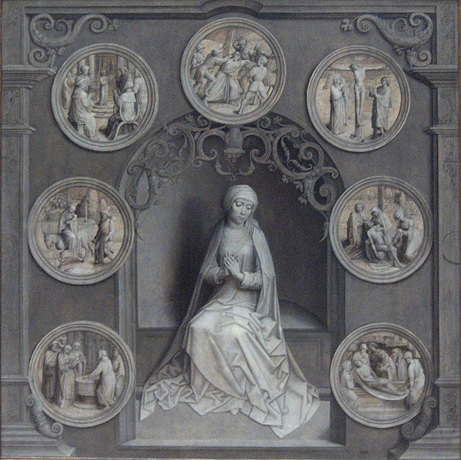
St. Mary of the Seven Dolors Catholic Church

